General Duplicate ID procedures
What? Duplicate ID’s in Banner happen when two records for the same student are created.

Contacts (need phone/email for each of these)
Dup. ID Committee: Working towards creating uniform procedures for correcting duplicate ID errors. If a dup id has information at multiple campuses and departments, report the issue to both of the main contacts for each MAU. Those contacts will take care of notifying the appropriate MAU area (Financial Aid, Admissions, Records, etc.) regarding the duplicate id cleanup.

UAA Contacts: Lora Volden (llvolden@uaa.alaska.edu) and Maryjean Rose (mjrose2@uaa.alaska.edu)

UAF Contacts: Crystal Goula (cagoula@alaska.edu) and Susan Culley (sjculley@alaska.edu)

UAS Contacts: Jeanny Wharton (jeanny.wharton@uas.alaska.edu) and Jan Crichton (jan.crichton@uas.alaska.edu)

SW Contacts: UA Scholars: scholars@alaska.edu
OIT Student: UA-OIT-EAS-STU-OC@alaska.edu
OIT HR: UA-OIT-EAS-HR-OC@alaska.edu
OIT Fin Aid UA-OIT-EAS-FA-OC@alaska.edu
Finance: sydevel@alaska.edu
HR: sdshr@alaska.edu or syhr@alaska.edu

How to Determine Which ID Becomes “Good”: These are not in a priority order. You will need to look at information on each record and the record with the bulk of the information
- Active HR records or paid records
- Active Financial aid or previous awarded aid
- Academic History; Degrees awarded, transcript comments, substantial graded records
- Admissions, substantial degree program history
- Payment history in Accounts Receivable
- Student active use and bio-demographics
- Is this a vendor record?
- Do they have a UA Scholar record?
- Does the person have a Pin # and have they accessed UAOnline?
- Does the person have a UA username and have they used it?
- Sequence of original and duplicate record.

Keep in mind that the records may be tied to OnBase and edir, too. Documents may need to be moved from bad ID in OnBase to the good id to make sure information is not lost.

OVERVIEW

BEFORE MAKING CHANGES
- Open 2 Banner windows – Helps with doing research and makes it easier to review records side by side.
- Do Research prior to making any changes. Use a worksheet or screen shots of Banner records to make notes. Use list above to plan consolidation of duplicate records. When practical, use the lowest (original) Banner ID. If appropriate, put an “*” asterisk in front of the last name field on the bad ID while it is being resolved. The * will help others realize this is a duplicate record, and prevent anyone from adding more data to this record. However, only putting an “*” does not mean you are done. Make sure you complete all of the required steps. Using SOAHOLD on both records might be needed to get the student to clarify which is the correct record and/or information.
- HR Records - If employee (HR) records exist on an ID, any proposed ID or record changes should be made on Monday-Thursday of a pay day week (a non-payroll processing week). Coordinate the proposed changes with the Statewide HR (syhr@alaska.edu) to avoid possible pay issues for the employee.
- Contact the appropriate departments at your MAU, based on what records exist for your campus, to assist with cleanup. If data is from another MAU or functional area, work with the contacts from that MAU, functional area, or statewide as necessary to consolidate.
- Keep record of consolidation and corrections by noting in SPACMNT. If necessary for your area, track any additional information.
- Prevention: Be sure training is provided to areas that have the potential to create duplicates. To help prevent duplicates, searches should be done using GUIALTI – that screen allows searching by SSN as well name and DOB. Make sure staff know how to use % as a wildcard for name searches in Banner.
- Rushes: Active students trying to transact university business should be rushed for ID resolution. Students living in housing, financial aid pending, currently enrolled for this semester, etc. will need to be cleaned up ASAP. If sending to OIT list for resolution, state in title “URGENT” so that on-call staff will know to rush.

RESEARCH:
Some suggested Banner screens to use for RESEARCHING record:

GUASYST,
GUIALTI (name searches)
SPAIDEN,
GOATPAC,
SPAAPIN,
SHACRSE,
SFAREGS,
SFI2RAT,
SAAADMS,
SGASTDN,
SOAHSCH,
SOAPCOL,
SOAHOLD,
SPACMNT.
SOATEST,
SRAQUIK,
SOA2USP (UA Scholars)
GOAINTL
SGAADVR
SGASADD
SHATCMT
SHAPCMP
TSAAREV
SHADEGR

This list is NOT inclusive of all the screens that you may need to use. If necessary, data from a screen may need to be transferred to the good record and/or deleted from the bad record.

In addition, you can also use GUR2PDM and GUR2MID reports to research duplicates. GUR2PDM pulls one id and lists tables for that id. GUR2MID compares data between two Banner ids and shows counts from those tables/fields. You can use these tables to identify which groups may need to be notified. If you are not familiar with the tables, use the GUASYST screen or see Appendix I in this document.

GUASYST

Form 1: GUASYST - Review GUASYST to determine which ID is “good” and which is “bad”.
- Make note of all information areas on the BAD ID that need to be changed or transferred to the correct number. GUASYST screen shots from both records are very helpful when working though duplicate id resolution.
- If both Banner IDs are human resources related, pass the information to human resources and stop here.
- Identify on GUASYST which groups are involved and notify appropriately. Cleanup data following your functional group instructions.
FORM 2: SPAIDEN/PPAIDEN/FOAIDEN – Use this form to change the ID number to a BAD ID.
If any item is checked under HR, make other record bad and keep this one as good. If both records have HR items checked, do not make any changes. Contact HR regarding these records.
Use appropriate MAU contacts
Use appropriate MAU contacts
Contact Finance
To see what campus:
Recruitng – look at SRAQUIK
Admissions – Look at SAAADMS
Transfer – Look at SHI2TCE
Registration – Look at SFI2RAT or SHACRSE
Housing – Look at SPAIDEN for housing address
Faculty – Look at SPAIDEN for HR address.

- In the ID key block enter the incorrect id.
- Ctrl page down into Current Identification tab. The cursor should now be in the ID field.
- Enter the “bad” number (i.e. BAD01_ _ _ ) into ID field. F10 to save. This will change the ID in the key block automatically. <BAD ID numbers coming from MAUs>
- Tab to Last Name and put an asterisk “*” in front of the last name. F10 to save.

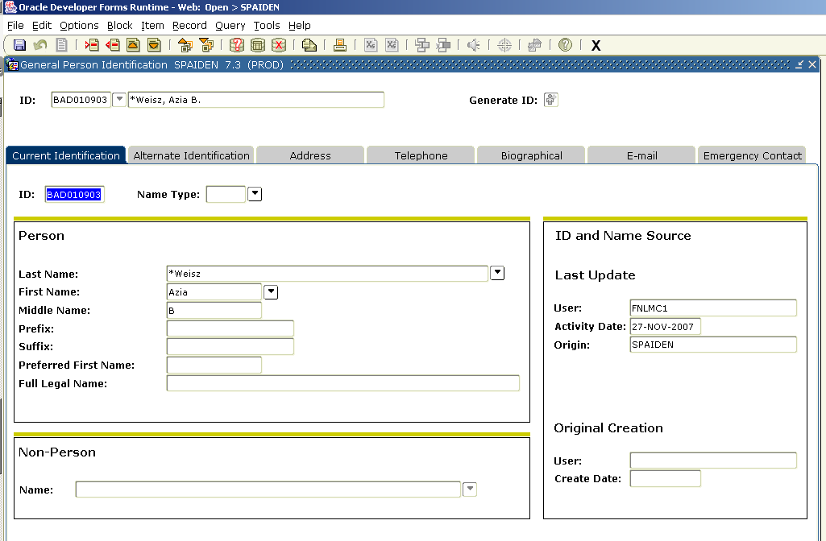

- Ctrl page down to OR click on Alternate Identification tab.
- If there are Alternate names other than the ones created by steps c and d, TRANSFER to Good record. This is CRITICAL as it can impact if a student can look up web application information or not.
- Shift-F6 to delete the alternate names associated with this id. F10 to save.
- Go to Address/Telephone/Email. Is the information on the bad ID different than what is on the good id? Are there address/phone/email types on the bad id that are not on the good id? On good record, add the addresses, emails and telephones. Once done, then go to bad ID and Shift-F6 to delete the addresses/telephones/emails. When you are finished, there should be no addresses on the bad record. F10 to save your changes on the address/telephone/email tabs.
- Continue to transfer information to good id then delete information from bad record on each tab on this form. F10 to save. NOTE: On Biographical tab make sure to clear Birth date field. Clear all data from this form, if possible, including SSN. All fields possible should be cleared.
- When finished, all SPAIDEN/PPAIDEN/FOAIDEN tabs except Current information tab should be clear on bad record.
FORM 3: SOAHOLD – this will prevent any registration on bad record while it is being resolved.

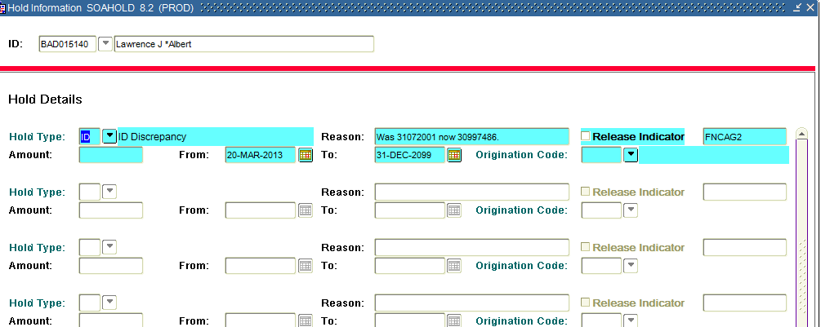

- On Bad record, go to SOAHOLD, and Ctrl page down.
- Enter Hold Type: ID
- Tab to Reason Field, enter: ID was 3YYYYYYY Now 3XXXXXXX. For 3XXXXXXX put the good id number, 3YYYYYYY is the bad id.
- Tab to Originator Code, type in appropriate code for your area and F10 to save.

FORM 4: SPACMNT – ENTER UNDER GOOD ID

- Ctrl page down.
- Enter Comment Type: DUP
- Enter appropriate code for you in the Originator field.
- Click or tab to Comments box and type: ADDL ID was 30000000 NOW SHOWN AS BAD000000. Good ID is 30000001. xxxx – where xxxx are your initials. The last updated field could be changed, so you want to make sure your initials are in the comment field.

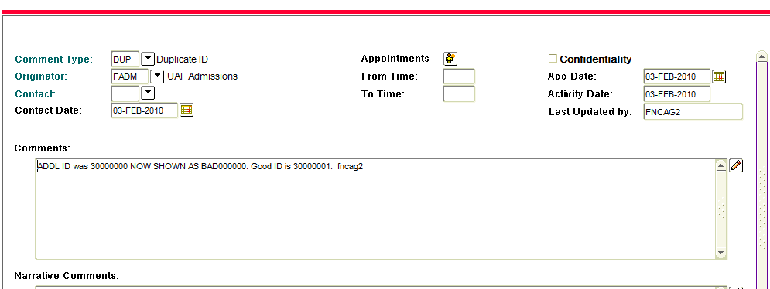

FORM 5 SPACMNT – ENTER UNDER BAD ID

- Ctrl page down.
- Enter Comment Type: DUP
- Enter appropriate code for you in the Originator field.
- Click or tab to Comments box and type: ADDL ID was 30000000 NOW SHOWN AS BAD000000. Good ID is 30000001. xxxx -- where xxxx are your initials. The last updated field could be changed, so you want to make sure your initials are in the comment field. Note any additional corrections or comments here also.

Double check OnBase for documents indexed to the bad ID:

In OnBase, go to Custom Query and perform a search for student file with old 3XXXXXXX number. As long as you do this search the same day, you can use the old 3XXXXXXX. If you wait until the next day or later, you will need to search using the BAD number you assigned in Banner.

If there are no documents under the old 3XXXXXXX or the BAD number, you are done.

If there are documents under the 3XXXXXXX id, you will need to reindex them to the correct ID. Do not use the Add/Modify Keywords option – this will not work. Always use the reindex option to make sure the document is attached to the correct ID information in OnBase.

If the documents have a different receiving campus than your campus, please notify the MAU contacts so that they can reindex the documents and determine if they need to go through the workflow process.

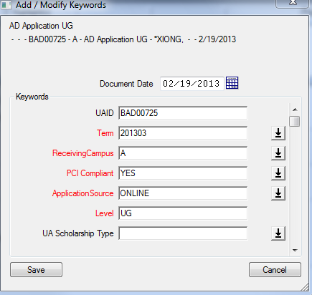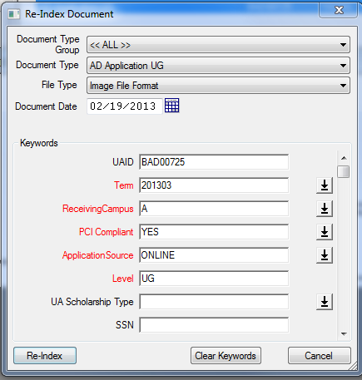

Appendix I

Table References:

F - Finance (FIMSMGR)
G - General (tables shared by > 1 functional area e.g., GOBEACC, GXRDIRD, GOATPAC, GOREMAL)
P - Payroll (HR tables)
N - Position Control (HR & POSCTL [Budget/Position] tables)
R - Financial Aid
S - Saturn/Student (some “S” tables are shared with other functional areas; e.g., SPRIDEN, SPRATELE, SPRADDR)
T - Accounts Receivable

WTAILOR - Web Tailor (OIT/EAS Tables)
OPS$SXHRS* - HR-related interim or testing tables from OIT/EAS processes/updates
SX*** - Table created by a specific user
SN*** - Table created by a specific user

