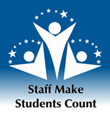

Schedule 2015

Wednesday, January 14 | Deadline for Monique Musick to transfer website and documents to Sys Gov Office
Monday, January 26 | Open nominations (4 wks)
Friday, February 20 | Close nominations
Monday, February 23 –Friday, March 6 | Two weeks for universities to select their winners - it is highly encouraged to include student governments in the selection.
Friday, March 20 at 5:00 p.m. | Deadline for universities to email winners to System Governance Office
Friday, April 3 | Winners to be submitted by System Governance Office to president for his approval
Friday, April 10 | President’s letter emailed and mailed to winners
Thursday, June 4 | Presentation of awards at board of regents meeting in Fairbanks

- Each university and Statewide send the selected winner’s nomination packet electronically through email to the System Governance Office attached with a spreadsheet of all the nominees’ names and contact information.

