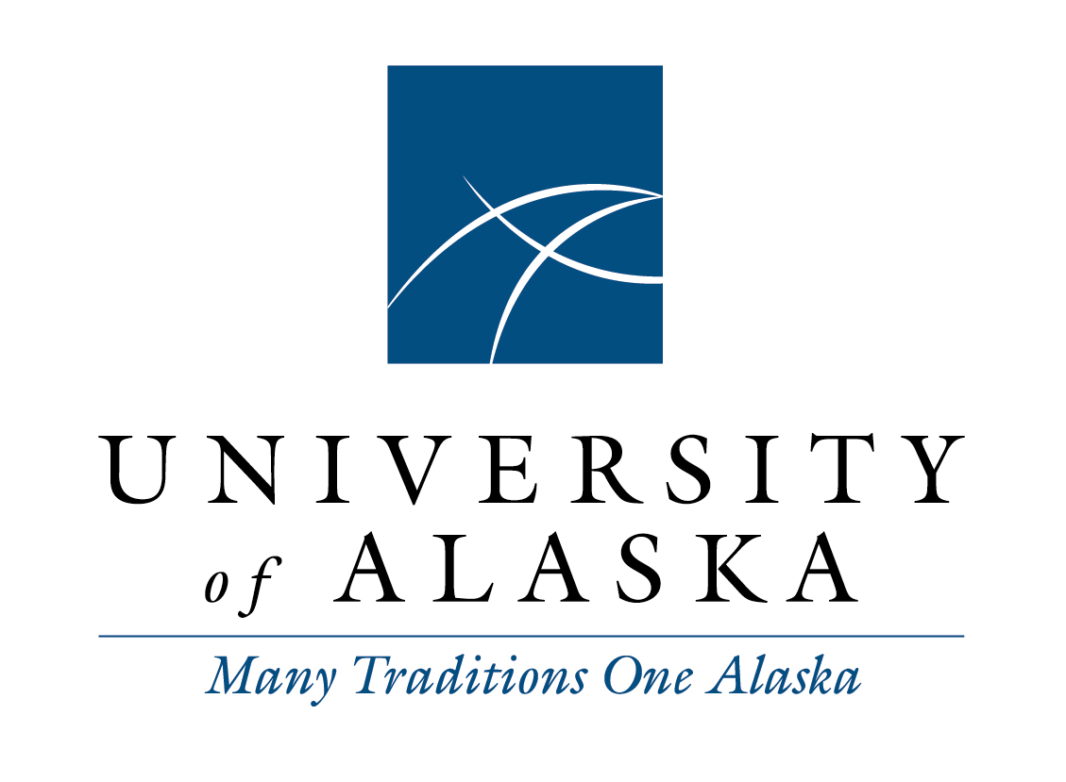

Staff Alliance
Meeting Minutes
Tuesday, February 10, 2015
10:00 a.m.-Noon
Via Google Hangout

Voting Members Present:
Monique Musick, Chair, Staff Alliance 2014-2015; Vice President, SAA 2014-2015
Kathleen McCoy, Vice Chair, Staff Alliance 2014-2015; UAA APT Council President 2014-2015
Dayna Mackey, Secretary, Staff Alliance 2014-2015; Vice President, UAS Staff Council 2013-2015
Faye Gallant, Treasurer, Staff Alliance 2014-2015; Vice President, UAF Staff Council 2014-2015
Chris Beks, President, UAF Staff Council 2014-2015
Tom Langdon, Representative, SAA 2014-2015 – arrived at 11:13am
Liz Winfree, President, UAA Classified Council 2013-2015

Staff:
LaNora Tolman, Executive Officer, System Governance
Joseph Altman, Coordinator, System Governance

Voting Members Not Present:
Marianne Ledford, President, UAS Staff Council 2014-2016 – will be joining meetings in March.

Guests:
Mike O’Brien, Associate General Counsel
Kit Duke, AVP Facilities and Land Management
Erik Seastedt, Chief Human Resources Officer
Erika Van Flein, Director of Benefits
Sara Rodewald, Healthyroads On-site Coordinator

Call to Order and Roll Call
Monique called the meeting to order at 10:03 a.m. Monique called roll.

Adopt Agenda and Approve Minutes
The agenda was motioned to adopt by Kathleen and seconded by Faye. The October 14, 2014 minutes were motioned by Kathleen and seconded by Monique. The November 11, 2014 minutes had an edit under “New Business”, tobacco free campus discussion to add tobacco to the second sentence to indicate “tobacco free to limited spaces” and were motioned with edits by Kathleen and seconded by Chris. The December 9, 2014 and January 13, 2015 notes were reviewed.

Guests Comments
Erik Seastedt talked in length about the layoff policy changes stayed throughout the meeting. Members voiced concerns about changing during a fiscal year just because of a crisis which makes staff uncomfortable. Staff wants to know why there is any difference of layoffs between exempt and nonexempt. The new proposed review process is unsettling due to the same person that decided the layoff is conducting the review. In addition to the review process, the understanding the layoff is for a legitimate business reason needs to be known. In reducing the months, not sure why there were six in the first place but things will not get better in a three month period to keep folks on. The suggestion was made to consider the emergency changes immediately and give governance more of a chance to review those not so emergency, Mr. Seastedt said he would take forward for consideration. There is also a concern about documented employee performance. If everyone were moved to a term status would there ever be a time that an employee could go back to a regular employee.

Sara Rodewald is the new Healthyroads Program Coordinator. Erika Van Flein has been forwarding all emails to the new Coordinator. She is able to answer incentive questions for those looking for more information. Another challenge will be introduced in March being able to log acitivites. There will be a WebEx in March online. This Friday, a Wellness Champion meeting will be held by audio. Biometric screenings are becoming available for each campus the first week in March until April 30th. Ms. Rodewald’s contact information is sararo@snhn.com, phone number 450-8203.

Kit Duke presented the Facilities Sightline Evaluation and Quadrant Chart. With the commitment to R&R that Governor Parnell committed to, UA buildings saw a decrease in age from 33 years to 25 years in just five years. The goal is for all campuses to get in the green and if they are not, evaluate and make suggestions to change.

Chair Report
Meeting with President included a discussion about cell phone subsidy which costs the university $350,000 annually. There was a change in 2010 to the plan but now is going away. Folks on call will still have phones but others will have to get their own. Staff Alliance has asked for expectations, along with, what to do if someone is not on call but needs to be reachable.

The emergency nature of the layoff was a discussion item. The President shared not everything will be asked for feedback within 15 days but would like to see faster responses amongst governance groups when asking for feedback. The Chair asked for a cover letter to help with the efficiency of receiving responses. To help with the layoff feedback, Chair did send message across systemwide listserv, however, not sure if all staff received email because listerv data is pulled from EDIR and is only as up to date as EDIR.

The discussion with the President included ways departments are exploring cost savings, the Foundation Office is piloting telecommuting for savings. This includes working one day a week from home.

The President provided an explanation to the new holiday naming of Chancellor’s Day which is a follow up on the origin of the day.

The Chair discussed with the President, the online vote of the sick leave policy and provided the resolutions and why UAA was not in support of.

Chris Christenson has been updating the State Relation site regularly to keep everyone up to date of what is happening in Juneau.

The President Search Committee will meet in conjunction with the next BOR meeting. The Chair will keep everyone updated.

The Chair is putting the next testimony together. The main discussion will be about budget and changes in policies. If anyone has anything else or great new stories to highlight staff, please send to the Chair.

Staff Alliance Committee Reports

Staff Healthcare Committee has not met.

Compensation Working Group have been waiting on FY16 budget news but will start back up now.

UA Core Values will be summarized and sent in but the report will focus on the difficulties of not knowing the context in order to organize and come together with a plan. Looking for more direction and intentions of what is expected.

External Committees
The Student Services Council met in January. A UAS staff member brought to the discussion about starting a doctorate program in Higher Education Leadership but with tight budget times, maybe a process to follow with a similar outcome through the Interdisciplinary doctorate program. Other topics included: admissions standards, student survey results, new student code of conduct, common calendar update, single UA GPA, and standardizing financial aid requirements.

Tuition Task Force did not meet. The BOR will be talking about an increase at their next meeting, it would be good to listen in to learn more.

Joint Health Care Committee no meeting.

Calendar Task Force, no committee members were present. The discussions coming out of the meeting include folks are willing to align spring breaks, however, efforts are continued in working with Alaska Airlines if the case this does happen. Overall, everyone seems pleased that it has been a good process.

Staff Alliance Blog
The Chair has encouraged folks to read old topics and make comments. BOR meeting, communication about President search, layoff regulation questions will be posted soon.

Ongoing Business Topics
Holiday regulation change (Chancellor’s Day) is still in the feedback stage. The idea is that the day will not be the same systemwide and is up to the Chancellor to decide where in the calendar the day will go.

VP of Academic Affairs search is down to three finalists. There is a new page on the statewide website that links to CVs to review.

Staff Make Students Count deadline is February 20th for campuses. Dayna asked for folks to review the criteria form that campuses use as a guideline in deciding recipients. It seems that the current criteria form doesn’t match the information being sent out to nominators to consider. An email will be sent out to review new criteria form.

Nothing new from the Summit Team but everyone is still encouraged to keep an eye on the initiatives website.

New Business
The Chair would like everyone to check that they have access to the review form through Google Docs.

Information on health plan changes are in the last Statewide Voice, this includes changes to deductibles.

The Chair will start feedback of layoff regulation and have ready through Google Docs by tomorrow.

Agenda Items for Next Meeting
Constitution and Bylaw changes. LaNora will repost on web for review.

Invite Chris Christenson to give a state update.

Next meeting is March 20, 2015

Meeting adjournment mentioned by Chris and seconded by Faye at 12:09pm.

Notes taken by Dayna Mackey, Secretary, Staff Alliance.

