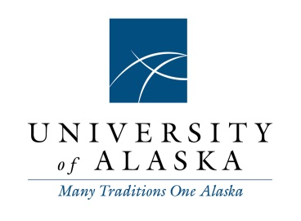
To: Staff Alliance
From: R. Erik Seastedt, Chief Human Resources Officer
Date: September 18, 2014
Re: Overview/intent of proposed Furlough Policy

In June of 2014, a proposed furlough policy was promulgated to the entire UA community. Since that time we have been receiving and actively soliciting feedback from all UA employees regarding the need for and impact of this policy.

Generally, administration feels that the ability to initiate furloughs is not, at this time, an option available as we move into more difficult financial times. Unfortunately, if the need arises to cut additional costs after all efficiencies have been examined and implemented, currently our only avenue available through policy and regulation would be to implement employee layoffs.

While not desirable, and certainly not a primary strategy for reducing expenses, furlough allows for a more humane way of affecting cost while less significantly affecting our work population. Many of our employees expressed their concern that they could not thrive if they had to go without pay or insurance for a block of time if the system shut down due to furloughing. We have worked to explain that furloughs for University purposes would look very different from the furloughs imposed on federal workers by the federal government. I have included a list of potential furlough options in the attached summary for your review.

It would be the intent of a furlough policy to reduce costs while yet preserving the health insurance and regular payment of our employees. Several employee groups have commented that while furloughs are not desirable, they could be palatable as long as insurances and regular paychecks continued. In the attached summary you will see more specifics related to what we believe the regulations that coincide with this proposed policy should reflect.

We are asking Staff Alliance to participate on a task force that would create draft regulations for the President’s approval. Human Resource Directors and others have also been invited to help shape potential regulations such that the impact of this policy, should it be approved by the BOR, would not be significantly detrimental to our employees.

