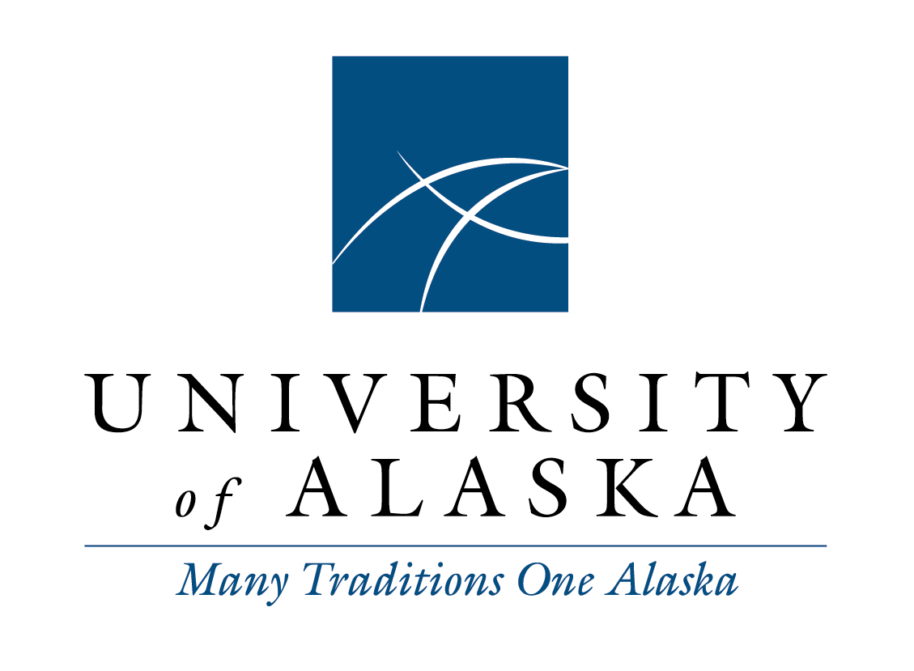

Staff Alliance
Minutes
Tuesday, March 10, 2014
10:00 a.m. – Noon
Via Google Hangout and audio Call-in

Voting Members Present:
Monique Musick, Chair, Staff Alliance 2014-2015; Vice President, SAA 2014-2015
Kathleen McCoy, Vice Chair, Staff Alliance 2014-2015; UAA APT Council President 2014-2015
Dayna Mackey, Secretary, Staff Alliance 2014-2015; Vice President, UAS Staff Council 2013-2015
Faye Gallant, Treasurer, Staff Alliance 2014-2015; Vice President, UAF Staff Council 2014-2015
Marianne Ledford, President, UAS Staff Council 2014-2016
Tom Langdon, Representative, SAA 2014-2015 – arrived at 11:13am
Liz Winfree, President, UAA Classified Council 2013-2015

Staff:
LaNora Tolman, Executive Officer, System Governance
Joseph Altman, Coordinator, System Governance

Voting Members Not Present:
Chris Beks, President, UAF Staff Council 2014-2015

Guests:
Toni Abby, OIT Project Manager
Mike Brase
Shelby Carlson
Russ, Risk Services
Deb Kouda

Call to Order and Roll Call
Monique called the meeting to order at 10:01 a.m. Monique called roll.

Adopt Agenda and Approve Minutes
The agenda was motioned to adopt by Kathleen and seconded by Liz. The February 10, 2015 minutes were motioned to adopt by Kathleen and seconded by Marianne.

Guests Comments
Legislative report was directed to email sent out statewide last Wednesday and a mention that increases may not be approved in November budget discussions for FY17.

Tony Abby talked about the new risk reporting software called Origami. This new system will eliminate paper forms and allow the opportunity to attach items to an online form. All websites will have a link to the online reporting by the end of the month.

Layoff regulation response from Staff Alliance was discussed. UAF passed a resolution in support of but the other entities did not. The question about evaluations still exist, can all universities agree to participate in a consistent evaluation process.

It has been discovered the furlough policy approved by BOR was a bit different than what was submitted by the furlough task force. A major discrepancy noted was the removal of max days, Faye will put together comments to send to Eric Seastedt by next Thursday and for everyone to vote on by Monday, March 30th. Staff Alliance members discussed their concerns about how processes and task forces providing comments and being changed with no comment period is concerning.

Chair Report
The President Search Committee will be meeting again after the next BOR meeting with the consultant. Interviews could be done with applicants or nominees suggested to consultant. If someone would like to nominate a person to be considered, the consultant will contact to discuss nomination. To nominate, please use the search website. The top 3-5 names will be forwarded to BOR for consideration. The timeline is to have everything done by April and names to BOR in May.

Governance report is due to BOR, some specific items includes processes and last minute changes, budget impacts, morale, and COLA.

Meeting between Chair and President was cancelled. Staff Alliance members encouraged Chair to reschedule due to these meetings being so important to know what to work on and follow up to inquiries.

Staff Alliance Committee Reports

Staff Healthcare Committee has not met. Will meet before end of the month and will invite Staff Alliance to discuss health changes that are being suggested by JHCC.

Compensation Working Group be meeting on March 26th at 10:30am. The group will discuss how staff are being compensated and convey to Administration what staff should be making so in better budgetary times they can refer to where increases should be. For those not on the working group and want to attend, LaNora can send invites for the meeting.

Nothing has been received from response sent to Summit Team regarding UA Core Values.

External Committees
The Student Services Council met in February. Discussions included gender neutral restrooms offered throughout each campus and gender neutral housing; new student code of conduct going through Administration to BOR; and change to state marijuana law does not change UA policy.

Tuition Task Force did not meet. BOR did discuss at last meeting and decided for a 5% increase for FY16. More discussions will continue for future fiscal years.

Joint Health Care Committee met for the month. Topics included: April 30th end of incentive period; low use of incentive, only 30.45%; decrease premiums over the next year; spouse possibly paying more to apply to affordable care act. Staff Alliance would like JHCC to consider changing to a single plan, maybe the state plan. Maybe all employees should be polled to see how satisfied they are with the health plans.

Calendar Task Force, no updates.

Staff Alliance Blog
Monique will post the layoff follow up from Erik Seastedt.

Ongoing Business Topics
Staff Make Students Count deadline has passed and names are due to LaNora by March 20th..

Nothing new from the Summit Team but everyone is still encouraged to keep an eye on the initiatives website.

Smoke free campus initiation: UAF has a Staff Council member participating with the Fresh Air Committee; UAA has a committee which Liz is participating; and UAS Vice Chancellors are discussing for implementing July 1st.

New Business
Use of electronic signatures regulation is being approved. Statewide OIT purchase Docusign two years ago and will be renegotiating this year, so far there has been no cost to UA for this item. Monique will put together a response expressing Staff Alliance’s support of.

Discontinuing employee personal mobile device except for those on call has been submitted. Tom proposed for Staff Alliance to support the mobile device change. Faye seconded and the resolution passed with all in favor.

The employee survey regarding voluntary reductions in pay or contract was discussed. Survey results have been sent to Statewide and waiting for more guidance on how staff can voluntarily start the process. Mr. Seastedt has said if some are already taking reductions and furlough is initiated, those staff will not receive additional reductions. Many wanted more clarification regarding retirement repercussions by cutting hours per week vs. months. Staff Alliance would like to see cost savings overall for voluntary reductions. Monique will send out information through staff listserv once a step by step guide is provided.

Agenda Items for Next Meeting
Constitution and Bylaw changes. LaNora will repost on web for review.

Legislative and policy changes, if any.

Next meeting is April 14, 2015

Meeting adjournment mentioned by Tom and seconded by Monique at 12:00pm.

Notes taken by Dayna Mackey, Secretary, Staff Alliance.

