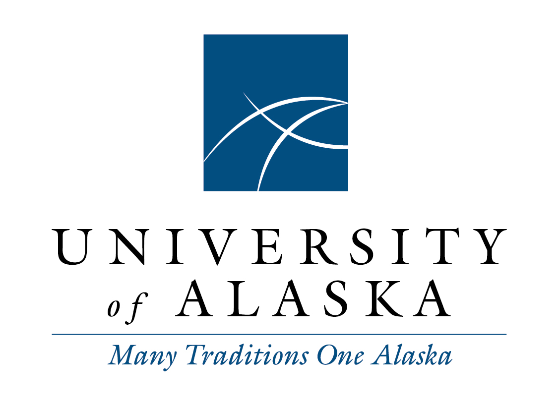

Faculty Alliance
Agenda
Friday, March 13, 2015
Via Google Hangout
1:00 p.m. – 3:00 p.m.

- Call to Order and Roll Call
Voting Members:
Mark Fitch, Past President, UAA Faculty Senate
Virgil Fredenberg, Past President UAS Faculty Senate
Maren Haavig, President-Elect, UAS Faculty Senate
Diane Hirshberg, President, UAA Faculty Senate
Kevin Krein, President, UAS Faculty Senate
Cècile Lardon, President, UAF Faculty Senate
Debu Misra, President-Elect, UAF Faculty Senate
Tara Smith, 1st Vice President, UAA Faculty Senate
David Valentine, Chair, Faculty Alliance; Past President, UAF Faculty Senate

Staff:
LaNora Tolman, Executive Officer, System Governance

Guests:
Rick Caulfield, UAS Provost, Acting VPAAR
Saichi Oba, Associate Vice President, Student and Enrollment Services
- Adopt Agenda
- Approve Minutes
  - January 16, 2015 (Minutes Attachment 1)
- Public or Guest Comments
- Report of the Chair
- New Business
  - Communication with statewide Human Resources concerning systemwide standard LMS use: syllabus, goals, grades
- Ongoing Business
  - Quick updates from retreat notes, including progress and projected dates
    - David: Letter to Presidential Search Advisory Committee with copy of Alliance letter to Regent Heckman and expressing concern over rush to select and how it impacts credibility of ultimate hire
    - David: Develop list of collaborative efforts, desires, and opportunities across the 3 universities
    - David: Develop Google Sheet for brainstorming items needed to attract and retain top/core faculty during difficult budget times
    - David: Thank you letter to common calendar task force members, cc: to President Gamble
    - David: Contact Karl Kowalski concerning coordinating LMS survey
    - Tara: Draft resolution supporting allowing written testimony to be read in advance of meetings and allowing oral testimony to be offered from other sites.
    - Kevin: Resolution or letter to President and BOR outlining FA support for maintaining 3 universities and drastically trimming statewide
    - Diane: Letter to BOR communicating our interest and desire to continue dialogue, capitalize on opportunities to interact with local faculty, etc.
    - Diane: Offer training to BOR on shared governance. Ask Chair Heckman what we should provide in addition to the AGB document she distributed at the January BOR retreat
    - Diane: Monitor “building partnerships” committee
    - Diane: Liason to Dayna DeFeo concerning college readiness addendum
  - Other items
  - Priorities and remaining target dates on items in FA issues spreadsheet
  - Student code of conduct status at UAF, UAS (Kevin, Cecile, March 15 report?)
  - Core values feedback/synthesis (Maren, Tara, Debu, timeline?)
- Committee Reports
  - Statewide Academic Council - David, Tara and Virgil
  - Student Services Council – Virgil and Tara
  - Tuition Task Force – Virgil and Tara
  - System Governance Council - David and Cècile
- Comments, concerns, and announcements
- Adjourn

