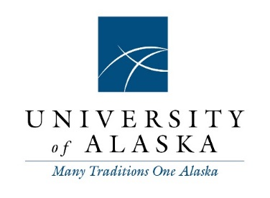

Agenda
Staff Alliance
Tuesday, August 6, 2019
4 p.m. – 5 p.m.
Zoom: https://alaska.zoom.us/j/9074508042
Audio: 1-699-900-6833
Meeting ID: 907 450 8042
(Please mute unless speaking.)

- Call to Order and Roll Call
Voting Members:
Crystal Duncan, Vice President, UAS Staff Council
David Felts, President, UAS Staff Council
Lauren Hartman, Vice President, SW Administration Assembly
Dawn Humenik, Co-President, UAA Staff Council
John Moore, Co-President, UAA Staff Council
Mathew Mund, President, UAF Staff Council
Carrie Santoro, Vice President, UAF Staff Council
Josh Watts, President, SW Administration Assembly

Staff:
Morgan Dufseth, Executive Officer, System Governance

- Adopt Agenda

- Public and Guest Comment

- Chair’s Report Josh Watts

- Staff Council Reports (5 minutes each)

- Updates and Information
  - July 30 BOR Decision Review – Agenda – Motion – Video
  - Legislative Update – Capitol Report

- Ongoing Business
  - Draft Resolution – BOR Meeting Recordings

- New Business
  - FY20 Meeting Schedule
    - Third or fourth Thursdays at 10am
    - First, second, or fourth Tuesdays at 3pm
    - Increased meetings through September?
  - Officer Elections
    - Officer Duties
    - Chair
    - Vice Chair
  - Retreat – Postpone to after September BOR meeting? Hold by video?
  - Single Governance Structure Under One UA
    - Staff Council/Senate – How should staff be structured?
    - General Assembly – How should staff, faculty and students coordinate and interact?
    - How to proceed – Ask the councils to develop proposals? Form a SA committee?

- Announcements

- Agenda Items for Next Meeting

- Roundtable discussion

- Adjourn

