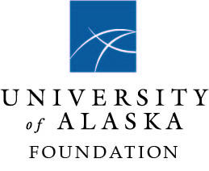

PRESS RELEASE

Save the date: UA fundraising campaign launches March 25

March 17, 2021

On March 25, the University of Alaska System will publicly launch its first-ever comprehensive philanthropic campaign. This campaign is a collaborative effort by UAA, UAF, UAS, and the UA System designed to empower opportunity through education in Alaska.
This is anticipated to be the largest public fundraising effort in Alaska’s history. The campaign aims to raise $200 million dollars for the University of Alaska.
Everyone is welcome to join in the celebration which will begin at 6 p.m. on Thursday, March 25, 2021. Diane Kaplan, a donor and President and CEO of the Rasmuson Foundation, will join as host of the virtual event.
All 16 University of Alaska campus communities will be participating and contributing to the campaign priorities that fit within four major theme areas:
- Expand the culture of education in Alaska - increase degree attainment, broad access,
student success, and educational equity
- Provide Alaska’s skilled workforce
- Grow UA’s world class research by leading research relevant to Alaska and to the arctic region
- Contribute to a more diversified economy by expanding Alaska’s knowledge base
This is an exciting moment in the history of the university system and Alaska. RSVP here for the virtual campaign launch.
Please visit www.uacampaign.com for more information or contact Tlisa Northcutt at tanorthcutt@alaska.edu or 907-786-1211.

