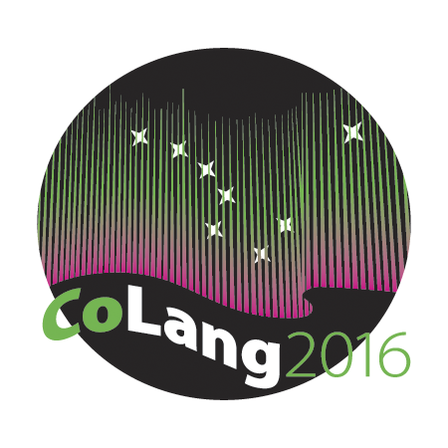

Colang 2016 Workshop Syllabus

Workshop Title: Language and Wellness
Instructor’s name and email: Doug Whalen (whalen@haskins.yale.edu); Alice Taff (alicetaff@gmail.com)
Course materials: Whalen, D. H., Moss, M. P., & Baldwin, D. (2016). Healing through language: Positive physical health effects of indigenous language use [version 1; referees: awaiting peer review]. F1000Research, 5(852). doi: 0.12688/f1000research.8656.1
Supplies needed: Projector for computer
Course goals: To give participants focused time to consider the issue of ancestral language use/learning and its connection to physical wellness; they can then design and implement their own projects based on the literature in this field, their workshop experience in project design, and their knowledge about credible outcomes and potential funding sources.
Student learning objectives: Students will become familiar with the literature on connections between language and health; they can then design and implement their own projects based on the literature in this field, their workshop experience in project design, and their knowledge about credible outcomes and potential funding sources
Instructional methods: Lecture, discussion, and student initiated research topics.
Evaluation: Workshops will be Pass/Fail. Full attendance is required for a pass in any workshop.
In addition, a one-page description of a possible research project linking language use and wellness will be required.

Disabilities services:
“The Office of Disability Services implements the Americans with Disabilities Act (ADA), and insures that UAF students have equal access to the campus and course materials. The instructor will work with the Office of Disabilities Services (208 WHIT, 474-5655) to provide reasonable accommodation to students with disabilities.”

