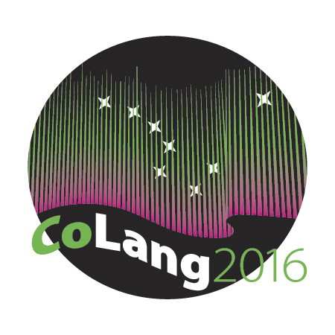

Colang 2016 Workshop Syllabus

Workshop Title: Consent, Rights, and Intellectual Property: Navigating Language Documentation, Archiving, and Research

Instructor’s name and email:
Susan Smythe Kung skung@austin.utexas.edu
Edward Alexander 1edward.alexander@gmail.com

Course materials: All suggested videos and readings are listed below in the daily schedule; see this bibliography for additional resources.

Supplies needed: Laptop or tablet to access online course materials and create final presentation.

Course goals: Introduce concepts of consent, rights and intellectual property in relation to language documentation, archiving, and research.

Student learning objectives:
Upon successful completion of this workshop, students should be able to:
- Identify the importance of consent, rights and intellectual property to researchers, documenters, archivists and language origin communities.
- Articulate how their own interaction with language documentation is informed by course concepts.

Instructional methods: Lecture, discussion, group activities, suggested readings.
Evaluation: The workshop will be Pass/Fail; full attendance is required for a pass. Students will be evaluated based on (1) their class attendance, participation and engagement, and (2) on a final presentation to be created in a slide show, lecture capture or animation program of their choice (e.g., Power Point, Keynote, Google Slides, Prezi, GoAnimate, etc.). This presentation must include either presenter notes (for slide shows) or voice over (for lecture capture or animation) in order to demonstrate an understanding of the concepts of consent, rights, and intellectual property and how these concepts affect their own current or future engagement with language documentation, revitalization, and/or research.

Disabilities services: “The Office of Disability Services implements the Americans with Disabilities Act (ADA), and insures that UAF students have equal access to the campus and course materials. The instructor will work with the Office of Disabilities Services (208 WHIT, 474-5655) to provide reasonable accommodation to students with disabilities.”

Preliminary Schedule and Suggested Readings and Videos

Day 1: The User Experience: Rights and Research
Kapsidelis, Katherine and Becca Pad. [utlibraries]. (2015, Feb. 24). Copyright and fair use. [Video file]. Retrieved from https://www.youtube.com/watch?v=nHmnjSR7bVM&feature=youtu.be.
Schmidt, Laura. (n.d.). Using archives: A guide to effective research. Retrieved from http://www2.archivists.org/usingarchives#.Vz4sxPmDFBc.
Suber, Peter. (2004, 2015). Open Access Overview. Retrieved from http://bit.ly/oa-overview.

Day 2: The Language Documenter Experience: Approvals, Permissions, Consent, Ownership

4 slide shows from Archiving ethically: Mediating the demands of communities and institutional sponsors when producing language documentation. Special session at the 2010 Annual Meeting of the Linguistic Society of American, Baltimore, MD:

Dobrin, Lise. (2010). Representing fieldwork to Your IRB. Retrieved from http://ailla.utexas.org/site/lsa_archiving10/dobrin_lsa2010.pdf.
Good, Jeff. (2010). Documenting consent, access, and rights. Retrieved from http://ailla.utexas.org/site/lsa_archiving10/jcgood_lsa2010.pdf.
Rice, Keren. (2010). Ethics in linguistic fieldwork: Consent in documentation and archiving. Retrieved from http://ailla.utexas.org/site/lsa_archiving10/rice_lsa2010.pdf.
Woodbury, Anthony C. (2010). Building projects around community members: The story of the Chatino Language Documentation Project. Retrieved from http://ailla.utexas.org/site/lsa_archiving10/woodbury_lsa2010.pdf.
Hovdhaugen, Even and Ashild Naess. (2011). Language is power: The impact of fieldwork on community politics. In Geoffrey L. J. Haig, Nicole Nau, Stefan Schnell, and Claudio Wegener (Eds.), Documenting endangered languages: Achievements and perspectives, 291-304. Berlin, Boston: De Gruyter Mouton.
Penfield, Susan, Angelina Serratos, Benjamin Tucker, Amelia Flores, Gilford Harper, Johnny Hill, Jr., and Nora Vasquez. (2008). Community collaborations: Best practices for North American indigenous language documentation. International Journal of the Sociology of Language 191:187-202.
(See especially section 4.2 on p. 192 and section 4.10 on p. 188.)

Day 3: The Language Community Experience: Intellectual Property and Cultural Implications
Christen, Kim and Chris Cooney. (2006). Digital dynamics across cultures. Vectors Journal 2(1) “Ephemera” Issue. Retrieved from http://www.vectorsjournal.org/projects/index.php?project=67.
(Click on “View Project” to get to the interactive site.)
Jackson, Jason B. (2010). Boasian ethnography and contemporary intellectual property debates. Proceedings of the American Philosophical Society, 154(1):40-49. Retrieved from https://amphilsoc.org/sites/default/files/proceedings/5Jackson1540105.pdf.

World Intellectual Property Organization. (n.d.). Traditional Knowledge and Intellectual Property – Background Brief. Retrieved from http://www.wipo.int/pressroom/en/briefs/tk_ip.html.

Day 4: The Archive Employee Experience and Wrap Up
Allen, Jennifer. (2016, May 4). Copyright and long-term storage issues in digital archiving and preservation. Retrieved from https://www.youtube.com/watch?v=95IYTx4boTQ&feature=youtu.be.
Holton, Gary. (2012). Language archives: They're not just for linguists any more. Language Documentation and Conservation 3:105-109. Retrieved from http://scholarspace.manoa.hawaii.edu/bitstream/handle/10125/4523/14holton.pdf?sequence=1.
O’Meara, Carolyn and Jeff Good. (2010). Ethical issues in legacy language resources. Language and Communication 30:162–170. Retrieved from https://www.acsu.buffalo.edu/~jcgood/OMearaGood-EthicalIssues.pdf.

