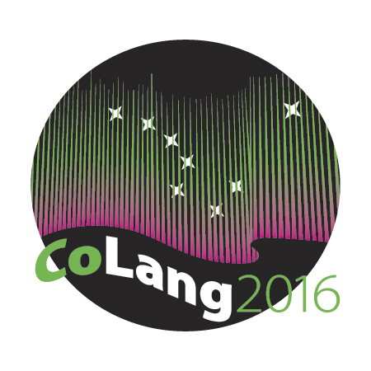

Colang 2016 Workshop Syllabus

Workshop Title: Audio Recording
Instructor’s name and email: Toshi Nakayama (nakayama@aa.tufs.ac.jp); Yoshi Ono (tono@ualberta.ca)
Course materials: Relevant materials will be provided in class
Supplies needed: laptop (please come having installed Audacity from: http://www.audacityteam.org/download/), headphones/earphones, audio recorders and mics (if you can)
Course goals: To cover principles of making and editing audio recordings for language documentation and language maintenance projects
Student learning objectives: Participants will learn the mechanics of audio recordings, skills for creating high quality audio recordings, knowledge necessary for making educated decisions about choice of equipment and recording environment.
Instructional methods: A combination of short lectures and hands-on exercises
Evaluation: Workshop performance will be evaluated on the Pass/Fail basis. Full attendance is required. Participants will do several small group exercises, the results of which they present and are evaluated on
Disabilities services: The Office of Disability Services implements the Americans with Disabilities Act (ADA), and insures that UAF students have equal access to the campus and course materials. The instructor will work with the Office of Disabilities Services (208 WHIT, 474-5655) to provide reasonable accommodation to students with disabilities.

