University of Alaska Systems

Disconnected Scanning
Training Manual

Contents
Logging into Disconnected Scanning 2
Scanning in a document from TWAIN 3
Scanning in a document from SWEEP 5
Document Separation 7
Uploading the Scanned in Document to OnBase 10
Indexing the Uploaded Document 11

Logging into Disconnected Scanning
The first time you log in, you may be prompted to go to the file location, it is under Computer>OSDisk>OnBase Printer Spool
- Enter the server address https://sw-dove.apps.ad.alaska.edu/appserver/service.asmx
- The domain will be UA
- User name should be autofilled in, otherwise use your UA username, the one you use to log into work computers.
- Password is your edir/elmo password
- Leave Datasource as the <default>
- Now click OK
You should only have to do most of this once. Every other time you launch Disconnected Scanning it will autofill everything except your password.
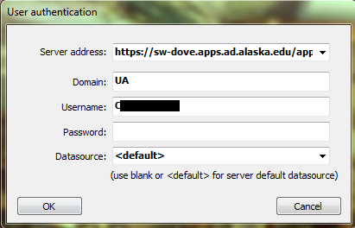

2 methods for scanning (Sweep and Twain)

Scanning in a document from TWAIN (Using the physical scanner)
- Now you will need to choose your scan queue
- Choose your source (scanner)
- Choose your format (single side, double side, landscape, portrait) (You might have to create some new formats, customizing for file types, color sensitivity, contrast, etc. Or you may need to modify existing formats, depending on the workstation)
- You can start and stop a scan as needed to change formats, or to continue a scan at a later time. To restart a scan, double click the batch as it is in the “awaiting index” folder on the sidebar. This will expand the batch so you can see documents within it. Right click on a document, and select “Scan more pages”.
- Some scanners have difficulty with colored pages or pages with fields of grey, so you may need to use formats that use greyscale rather than B&W for such pages.
- Then make sure you have your documents/batches properly prepared. Staples must be removed, and sticky notes/attached pieces of paper should either be taped down, or removed, depending on your department's discretion. Loose edges part way down a paper may jam the scanner, and must be reinforced and held down. Pages must be unwrinkled/bent and any torn edges will be fragile and must be treated carefully. There should be no tape hanging off edges, or covering holes, as loose tape may cause pages to stick to each other, or to the scanner.
- After you are sure pages are prepared to scan, line the edges up neatly in a stack, and place them face down in the scanner tray, with the top of the page going into the scanner first.

Lorem ipsum
Sample text
Lorem ipsum
Etc etc
Sample sample

Top, face
Bottom, face
Top Back
Bottom, Back

Top, back

Bottom, back

- Begin the scanning by going to File --> Scan new batch

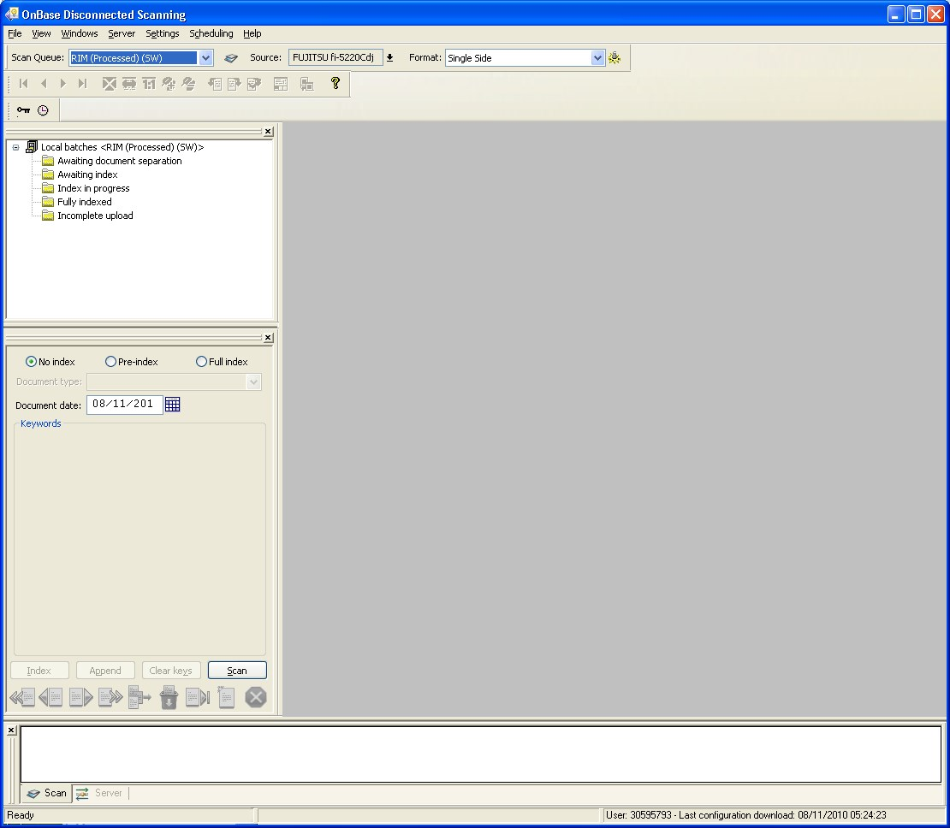

- Once you have scanned your batch, you will have a window pop up prompting you to name the batch.
- Your batch naming conventions are determined by the business processes your department has.
- Once you enter your batch name, click OK you will be able to watch the documents scanning in on the gray screen in the center of the window.
- When the scanner has pulled all pages through, it will prompt you to choose between finishing the scan, starting a new document, or deleting the batch/document.

Scanning in a document from SWEEP (Using previously scanned images that are on the computer)
- Change your Source from Scanner to Disk
- Now you will need to choose your scan queue
- Choose your format (Name it by clicking on the yellow gear icon right of the drop down box , this is where you can add new formats as well.)
- Begin the scanning by going to File --> Scan new batch or by clicking the scan button below
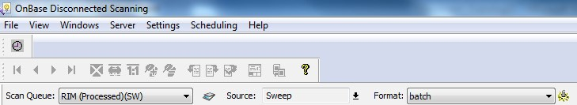
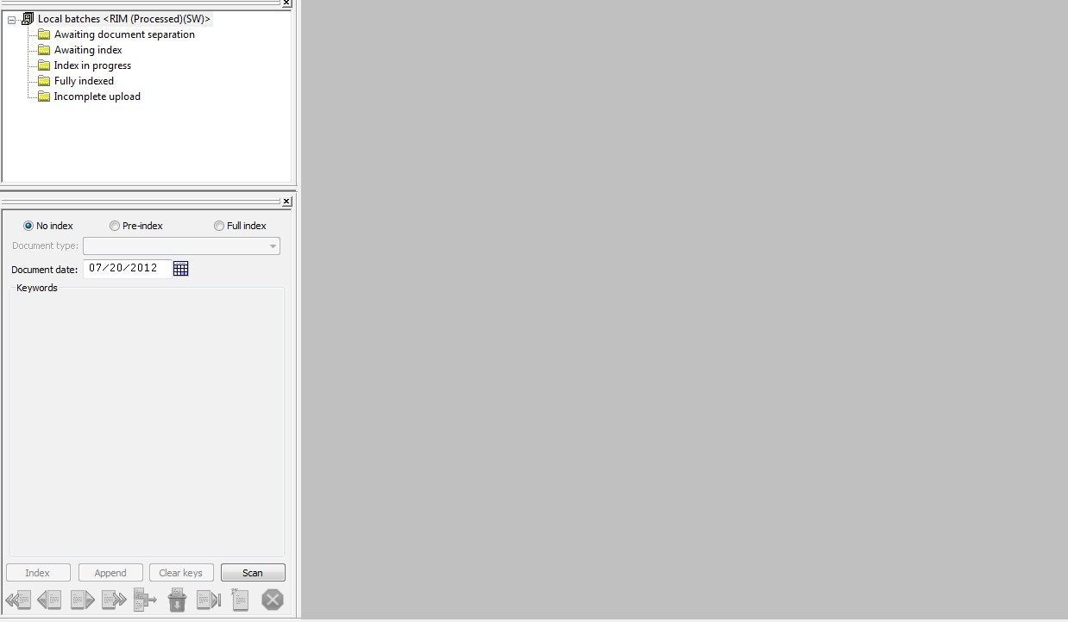
- Once you have scanned your batch, you will have a window pop up prompting you to name the batch.
- Your batch naming conventions are determined by the business processes your department has.
- Once you have input your batch name, press Ok, and the new window below will show.
- Choose your file/sweep path, which folder has the files you need.
- Your file name should be *.* which means that it will add all of the files currently in that folder and you may check the “Only sweep images” option if you would only like images to be processed.
- If you do not check it, all files in the folders will be scanned in as is no matter the file type.
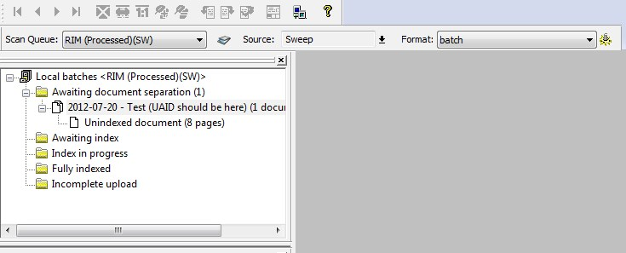
- Once you have successfully scanned in your documents through Sweep, your batch names will be shown in the sidebar, as in the image above. To view your scanned images, double-click on a document.

After scanning from (TWAIN or SWEEP)

NOTE: For both Twain and Sweep, after scanning in a document, it will be processed the same way.

Document Separation
- The first folder the batches will enter is the “Awaiting document separation”
- Click on awaiting document separation then click the batch you scanned in.
- Then right-click on the batch to choose either “Perform document separation” or “Skip document separation.”
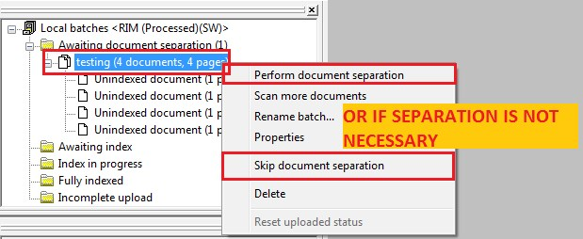
- If you choose to perform a document separation you will see this screen. 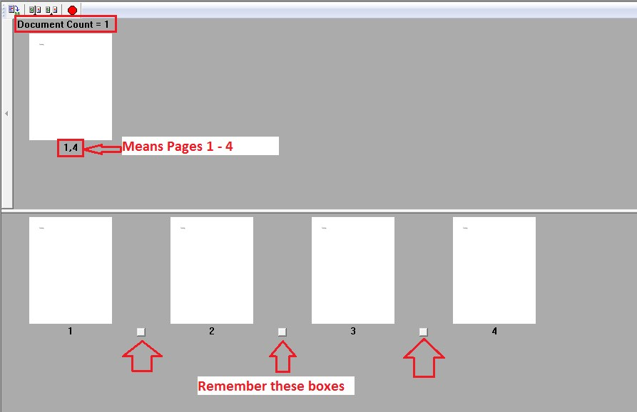
- As the default, there is 1 document and however many pages when scanned.
- These documents can be separated into several documents with a certain amount of pages in them.
- For example, we have 4 pages and 1 document. We can separate the pages into 3 documents in which:
  - Document 1 holds 2 pages
  - Document 2 holds 1 page
  - Document 3 holds 1 page

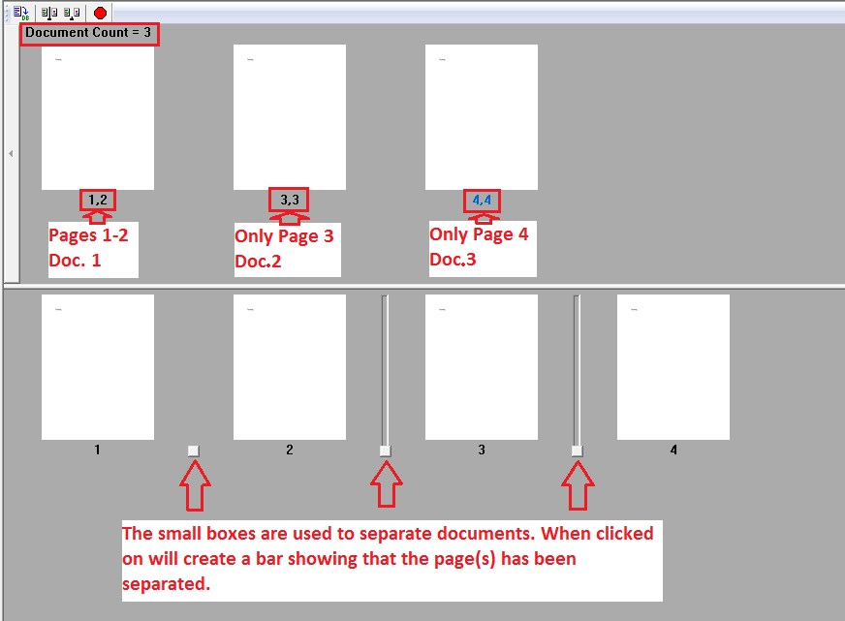

• Once you have completed your document separation you will have 4 choices
• The 1st icon is to save your document separation
• The 2nd icon is to separate each page in the document
• The 3rd icon is to un-separate the pages you separated
• The 4th icon (looks like a stop sign) is to cancel the document separation
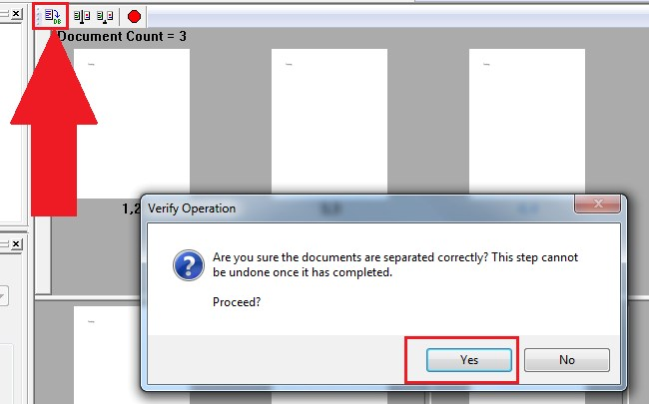

- After the documents have been separated, of if you skip document separation, They will move into the “Awaiting Index Folder.”
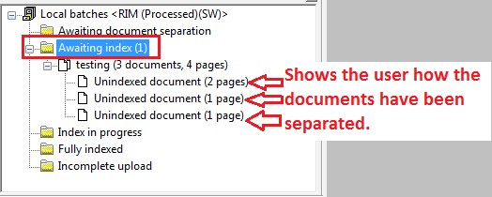

Uploading the Scanned in Document to OnBase
- Because we DO NOT index in the disconnect scanning system you must choose upload batch
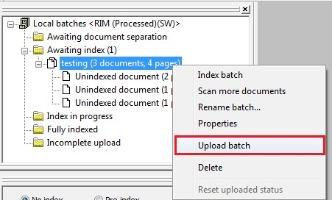

- Once you choose upload batch you will get another verifying window. This is to let you know that you have not indexed the batch yet. Choose YES

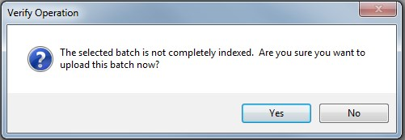

Indexing the Uploaded Document
- Now open OnBase.
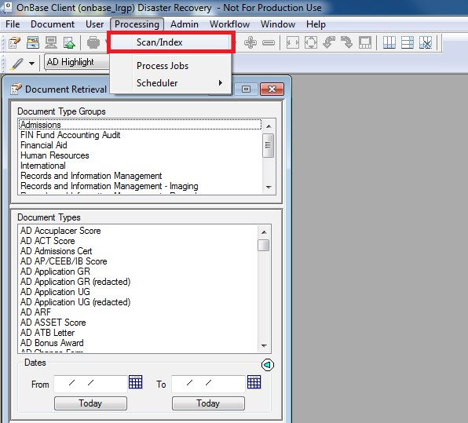
- Click on Processing →Scan/Index.
- The “Document Imaging” window will pop-up.
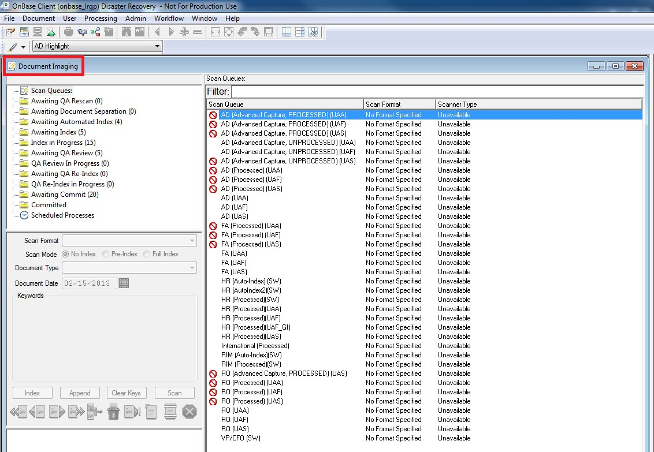

- In the “Awaiting Index Folder,” find your batch. You may be able to see other people’s batches that are being processed, but that is okay, just focus on your batch.
- Right-click and “Index Document.”
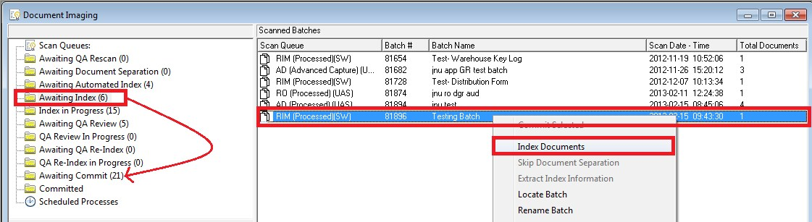
- Fill in the document type and keywords, then hit index. (Shown below is an Example)
  - When you scan a batch that has several separate documents inside, they will appear as one batch when you go to index them. Once you start indexing they will split into several documents that you index separately. They will also be separate documents once they are committed. They are only connected before they are indexed.
  - While indexing you will be able to view your document. You may find some pages have been scanned upside down, or sideways, and to correct this you right click on the page, select “Process” and then flip the image however you need.

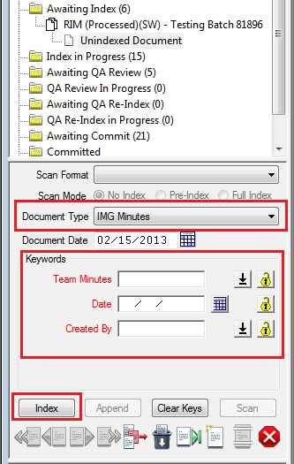

- The document is now in the “Awaiting Commit Folder.”
- Right-click the document and click “Commit Selected.” Committing is done so that the Meta data is held in the backup storage.
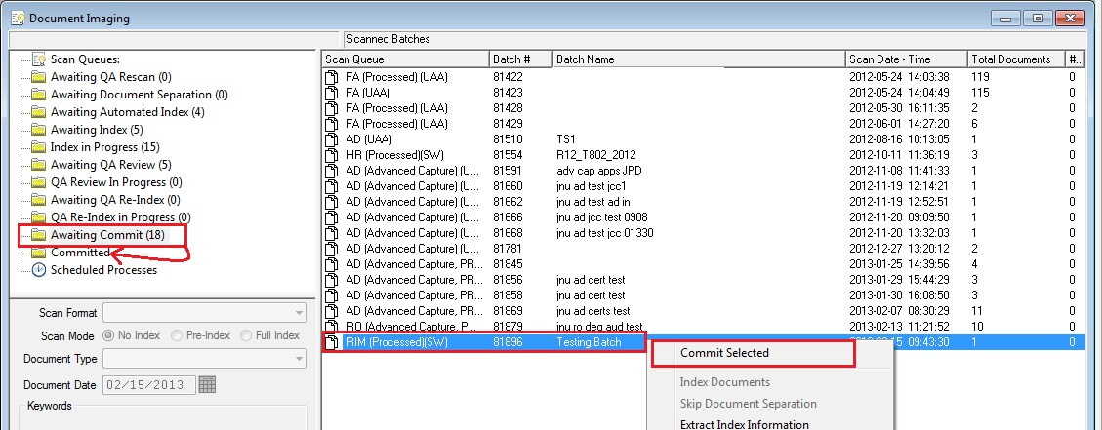
- The document should now be in the “committed folder” and can be searched in document retrieval.
- Scanning, indexing, and committing of the batch is complete.

