ITSM Process Description

Office of Information Technology

Change Management

Table of Contents
Introduction 5
Change Management Process Goals and Objectives 5
Scope 5
Benefits 6
Benefits to IT Service Providers 6
Benefits to Customers 7
Process Requirements 7
Key Terms and Definitions 11
Roles and Responsibilities 14
Change Management Process Owner 14
Change Manager 15
Change Coordinator 17
Change Advisory Board (CAB) 17
Change Tester 18
Change Implementer 18
Emergency Change Advisory Board (ECAB) 18
Change Management High Level Process 20
0.0 Change Management High Level Process Flow 20
0.0 Change Management High Level Process Descriptions 21
Record and Review Process 23
1.0 Record and Review Process Flow 23
1.0 Record and Review Process Activity Descriptions 24
1.0 Record and Review Process RACI Matrix 27
Prioritize and Categorize Process 28
2.0 Prioritize and Categorize Process Flow 28
2.0 Prioritize and Categorize Process Activity Descriptions 28
2.0 Prioritize and Categorize Process RACI Matrix 31
Normal Change Process 32
3.0 Normal Change Process Flow 32
3.0 Normal Change Process Activity Descriptions 33
3.0 Normal Change Process RACI Matrix 36
Build and Test Process 37
4.0 Build and Test Process Flow 37
4.0 Build and Test Process Activity Descriptions 38
4.0 Build and Test Process RACI Matrix 40
Deployment Process 41
5.0 Deployment Process Flow 41
5.0 Deployment Process Activity Descriptions 42
5.0 Deployment Process RACI Matrix 44
Review and Close Process 45
6.0 Review and Close Process Flow 45
6.0 Review and Close Process Activity Descriptions 46
6.0 Review and Close Process RACI Matrix 49
Emergency Change Process 50
7.0 Emergency Change Process Flow 50
7.0 Emergency Change Process Activity Descriptions 51
7.0 Emergency Change Process RACI Matrix 58
Standard Change Process 60
8.0 Standard Change Process Flow 60
8.0 Standard Change Process Activity Descriptions 61
8.0 Standard Change Process RACI Matrix 64
Process Performance Reports 65
Senior Management Reports 65
Report Structure 65
Middle Management Report 66
Report Structure 66
Stakeholder Reports 66
Report Structure 67
Critical Success Factors and Key Performance Indicators 68
Change Types Explained 69
Standard Change 69
Normal Change 70
Emergency Change 70
OIT Change Advisory Board (CAB) 71
CAB Procedures 71
ECAB Procedures 72

Introduction

The purpose of this document is to provide a detailed overview of the Office of Information Technology Change Management process. The document consists of detailed process flow diagrams, with procedures and corresponding RACI (Responsible, Accountable, Consulted and Informed) matrix and procedure descriptions.

Change Management Process Goals and Objectives

The Change Management Process goals and objectives define why Change Management is important to OIT’s overall vision for delivering and supporting effective and efficient IT Services. This section establishes the fundamental goals and objectives that underpin Change Management. The agreed and documented goals and objectives provide a point of reference to check implementation and operational decisions and activities.

The process goal is a broad statement that defines what the organization wants to achieve by successfully implementing Change Management. The process objectives are more specific statements than the purpose and are characterized by a set of tasks in pursuit of reaching the goals.

The goal of the change management process is to control the lifecycle of all changes, enabling beneficial changes to be made with minimum disruption to IT services.

The objectives of the Change Management process are to:

- Respond to the Customer’s changing business requirements while maximizing the value and reducing Incidents, disruption, and rework
- Respond to the business and IT Requests For Change (RFCs) that will align the services with the business needs
- Ensure that changes are recorded and evaluated, and that authorized changes are prioritized, planned, tested, implemented, documented and reviewed in a controlled manner
- Ensure that all changes to configuration items are recorded in the configuration management system
- Optimize overall business risk
- Ensure standardized methods and techniques are used for efficient and prompt handling of all changes to IT Services in order to meet agreed service levels and to prevent the occurrence of any change-related incidents

Scope

Scope refers to the boundaries or extent of influence to which Change Management applies. This section provides the scope for Change Management in regards to the process itself, Customers, Service Providers and IT Service and Service Components and environment.

The Change Management process scope will cover all IT Services, Configuration Items, Processes and Documentation. All changes are subject to a Request for Change (RFC) and must follow the Change Management process. Change Management scope covers all changes to any of the five aspects of service design: the solution, management information systems and tools, technology architectures, processes and measurement systems.

All Change Management activities referred to in this document should be implemented in full, operated as implemented, measured, and improved as necessary.

Benefits

There are several qualitative and quantitative benefits that can be achieved, for both the IT Service Providers and the Customers, by implementing an effective and efficient Change Management process. The Change Management Project Team has agreed that the following benefits are important and will be assessed for input to continuous process improvement throughout the Change Management process lifecycle.

Benefits to IT Service Providers

- Increased insight into the objective of, and how to contribute to, the Change Management process
- Better streamlined process and information for initiating Changes
- Increased visibility and communication of Changes to IT staff
- Contributing to better estimates of the quality, time and cost of change
- Better use of resources, prioritization of effort and planning of Changes
- Fewer Changes that have to be remediated, along with an increased ability to do this more easily when necessary
- Improved information and reporting for management guidance, continuously improving the Change Management process and providing integration with related processes
- Increased productivity of IT staff through less need for implementing urgent Changes or back-out activities
- Greater ability to absorb a large volume of Changes
- Better control over Change related contractor, vendor or project activities
- Better business perception of the IT department through an improved quality of service and a professional approach

Benefits to Customers

- Implementing changes that meet the business’ agreed service requirements while optimizing costs
- Contributing to meet governance, legal, contractual and regulatory requirements
- Increased insight into the objectives and contributions of Change Management process
- Better alignment of IT services to the actual business and user requirements
- Better streamlined process and information for initiating Changes
- Increased visibility and communication of Changes to business and users affected
- Reduced adverse impact of Changes on the IT services and Service Levels by improved impact and risk assessment
- Increased productivity of users through fewer disruptions (higher service availability) and higher-quality services

Process Requirements

Process Requirements for Change Management represent decisions made by the Change Management Process Owner and Change Management Project Team for end-to-end management and execution of the Change Management Process. All technologies, organizations and staff defined in the Change Management Scope are expected to adhere to these Process Requirements.

The Process Requirements for Change Management are designed to ensure that all Service Provider organizations work together to successfully meet the Change Management Goals.

The Change Management Process Requirements are owned and monitored by the Change Management Process Owner. The Process Owner will provide Management Information to senior- and middle-managers to demonstrate overall Process effectiveness and efficiency, compliance at an organizational level and compliance at a department and individual level. The Change Management Process Owner is also accountable for ensuring that Process Requirements for Change Management add value to the organization and are reviewed and updated no less than on a quarterly basis.

Requirement | Reason For Requirement | Benefits
One Change Management process will be utilized throughout OIT | To ensure consistent and quality delivery of IT services to customers and to minimize change-related Incidents as a result of changes to the IT infrastructure. | - Improved availability through the minimization of Change-related incidents  - Consistency in service delivery  - Improved customer communication and satisfaction  - Improved management information
The Change Management Process Owner is accountable for the OIT Change Management process and authorizes modification of process requirements and procedures. | To provide a single point of accountability for the Change Management process across OIT. | Ensures consistency in the execution of Change Management across OIT.
All Changes will be coordinated through a single focal point (e.g.: Change Manager, Change Process Owner, CAB). | To minimize the probability of conflicting changes and potential disruption to the production (live) environment. | Eliminates disruption to the live environment because of conflicting Changes and/or too much change at one time.
All Changes must be registered, authorized and implemented through the Change Management process. | Helps to create a culture of Change Management throughout the organization. | - Better alignment of IT services and business needs  - Increased visibility and communication of Changes  - Reduction of negative impacts of Change on IT services from improved business and technical impact and risk assessment  - Improved user productivity and higher quality services due to fewer disruptions  - Greater ability to absorb large volume of Changes  - Single repository provides a consistent, unified view of all in-scope Changes
A Request for Change (RFC) must be submitted in time for appropriate assessment prior to authorization and implementation.  Lead times are dependent on the type and categorization of a change and are documented in the organization’s Change categorization workflow. | Provide adequate time to properly evaluate and plan for authorization, approval and implementation of a Change, while minimizing Emergency Changes and the impact on the organization. | - Ensures that all Changes have been assessed for risk and impact  - Provides an increase in customer satisfaction and reduction of Incidents or Problems as a result of Change  - Maintains service availability and Service Level Agreements (SLAs)
The Change Manager (with input from the initiator and other stakeholders) will allocate a priority for every RFC that is based on the impact to the business and the urgency for implementing the Change. This priority rating is used to decide which Changes should be discussed and assessed first by the Change Advisory Board (CAB). | To ensure common guidelines and standards are used for the prioritization of any RFC. | Ensures appropriate efficiency by determining the sequence in which a Change will be put forward based on impact and urgency
A Forward Schedule of Changes will be published. All requested and approved changes with their status will be listed. The Forward Schedule of Change will be reviewed at each CAB meeting. | The universe of Change is understood; reduces the chance that conflicting changes will introduce risk of unintended consequences into the Production Environment | Reduces the likelihood of unintended consequences to any change or group of changes.
The definition of an Emergency Change is: A Change that must be introduced as soon as possible such as those to resolve a Major Incident or implement a Security patch. | Ensure that standardized methods are used for process Emergency changes in order to prevent change-related incidents | - Ensures prompt handling of changes  - Allows for Assessment of risk, impact to (IT and the business) and resource requirements for Emergency Change requests  - Maintains effective communication with both IT staff and business users even during an Emergency.
Emergency Changes require Emergency Change Advisory Board (ECAB) approval. | Ensure that as little risk as possible is introduced into the production environment during a change | Ensures that the risk of business service interruption during a change is minimized
Access to alter the production environment is controlled, and access rights are only given to those people who are authorized to make changes. | Prevents people who are not authorized to make a Change from having access to the production environment. | - Ensures that appropriate checks and balances are achieved.  - Decreases the risk of unauthorized Changes and potential disruption to the production environment
All Changes require successful completion of testing before being implemented into the production environment when there is a test environment in place. At a minimum, validation in the production environment must occur when no test bed is available. Every change will have a test or validation plan in place. | Ensures that any Changes are tested prior to being implemented into the production environment and any Emergency Change not tested prior to implementation requires risk analysis and approval. | Reduces the likelihood for failed Changes and the subsequent cost to Customers for unplanned downtime.
All Changes to the production environment will be made within agreed Change windows. Any exceptions will be agreed and communicated. | To ensure that service downtime to implement changes is done during agreed and communicated timeframes. | Reduces impact to the users and allows them to plan their work according to communicated service outage windows.
All changes that impact service capability will be assessed for performance and risk and resources needed to implement the Change. Based on the assessment, categorization will be used to identify the level of authorization required for a Change. | To ensure that a Change is assigned a category. This will provide the information required to define the level of authorization. | Provides increased customer availability and ensures proper authorization levels for changes
Standard Changes must be implemented using the accepted and established procedure. All Standard Changes will be recorded in the Change logging system. | Standard Change processes and associated Change workflows should be developed and communicated to ensure that such Changes are efficiently processed to support the organization’s business needs. | - Ensures efficient and prompt handling of Change requests.  - Improves customer service levels
All Emergency Changes will be reviewed at the CAB in retrospect. | Assessing the effectiveness of an Emergency Change. | To ensure there is effective oversight and review of Emergency Changes and proper communication.
Every Change will receive a post implementation review. All less than successful changes will receive a more extensive review. | Clarify the responsibility of the CAB to perform Post Implementation Review for all Changes after they have been implemented. | Assures that all Changes are reviewed for learning opportunities after they are implemented.
Change Management metrics and management reports will be provided to Management and Customers in accordance with outlined procedures and agreements. | Assessing performance measures (e.g., efficiency and effectiveness) of the Change Management process. | - Communicates Incidents and Problems as a result of a Change  - Provides trend analysis  - Identifies opportunities for improvement
Reviews are conducted by the Process Owner and the CAB on a minimum of a quarterly basis based on the analysis. Reviews will focus on the process consistency, repeatability and Key Performance Indicators (KPI).  Results are communicated with the Change Managers, Change Coordinators, CAB members and management, as appropriate. | Maximize process benefits and reduce costs. | Process improvement

Key Terms and Definitions

Business Unit: A segment of the Business which has its own plans, metrics, income and costs. Each Business Unit owns Assets and uses these to create value for Customers in the form of goods and Services.

Change: The addition, modification or removal of anything that could have an effect on IT Services. The Scope should include all IT Services, Configuration Items, Processes and Documentation.
Change Advisory Board (CAB): A group of people that advises the Change Manager in the assessment, prioritization and scheduling of Changes. This board is usually made up of representatives from all areas within the IT Service Provider, representatives from the Business and Third Parties such as Suppliers.

Change Management: The process for managing the addition, modification or removal of anything that could have an effect on IT Services resulting in minimal disruption to services and reduced risk. The Scope should include all IT Services, Configuration Items, Processes and Documentation.

Change Proposal: A documented high level description of a potential service introduction or significant change, along with a corresponding business case and expected implementation schedule. Normally created by the Service Portfolio process and passed to Change Management for assessment and authorization prior to the service charter is approved.

Change Record: A Record containing the details of a Change. Each Change Record documents the Lifecycle of a single Change. A Change Record is created for every Request for Change (RFC) that is received, even those that are subsequently rejected. Change Records should reference the Configuration Items that are affected by the Change. Change Records are stored in the Configuration Management System (CMS).

Change Schedule: A document that lists all authorized changes and their planned implementation dates, as well as the estimated dates of longer-term changes.

Configuration Management System (CMS): A set of tools and databases that are used to manage an IT Service Provider’s Configuration data. The CMS also includes information about Incidents, Problems, Known Errors, Changes, and Releases; and may contain data about employees, Suppliers, locations, Business Units, Customers, and Users.

Customer: Someone who buys goods or Services. The Customer of an IT Service provider is the person or group who defines and agrees the service level targets.

Emergency Change: A Change that must be introduced as soon as possible; for example, to resolve a Major Incident or implement a Security patch. The Change Management Process will normally have a specific Procedure for handling Emergency Changes.

Emergency Change Advisory Board (ECAB): A subset of the Change Advisory Board that makes decisions about high impact Emergency Changes. Membership of the ECAB may be decided at the time a meeting is called, and depends on the nature of the Emergency Change.

External Review: Certain Changes may require the review of an external group(s) prior to approval. External review may also be required for the following:

- Outside review of Test results
- Functional User approval for scheduling
- Functional User approval for requests from other users
- Needs higher level approval (Director/CITO/etc)- conflicts the CAB is unable to resolve
- Any change impacting another MAU or community campus

Functional Unit: A team or group of people and the tools they use to carry out one of more processes or activities; for example, the Service Desk.

Impact: A measure of the effect of an Incident, Problem or Change on Business Processes. Impact is often based on how Service Levels will be affected.
IT Service: A Service is a means of delivering value to Customers by facilitating outcomes Customers want to achieve without the ownership of specific costs and risks. An IT Service uses Information Technology to support the Customer’s business processes.

Operational Level Agreement (OLA): An Agreement between an IT Service provider and another part of the same organization. An OLA supports the IT Service provider’s delivery of IT Services to Customers. The OLA defines the goods or Services to be provided and the responsibilities of both parties.

Request for Change (RFC): A formal proposal for requesting a Change is made. An RFC includes details of the proposed Change, and may be recorded on paper or electronically. The term RFC is often misused to mean a Change Record, or the Change itself.

Service Catalog: The Service Catalog is a database or structured document with information about all Live IT Services including those available for Deployment. The Service Catalog is the only part of the Service Portfolio published to Customers and is used to support the sale and delivery of IT Services. The Service Catalog includes information about deliverables, prices, contact points, ordering and request Processes.

Service Level: A Service Level is a measured and reported achievement against one or more Service Level the designated person, team or group. Some process roles may be full-time jobs while others are a portion of a job. One person or team may have multiple roles across multiple processes. Caution is given to combining roles for a person, team or group where separation of duties is required. For example, there is a conflict of interest when a software developer is also the independent tester for his or her own work.

Service Level Agreement (SLA): A SLA is an agreement between an IT Service Provider and a Customer. The SLA describes the IT Service, documents service level targets, and specifies the responsibilities of the IT Service provider and the Customer. A single SLA may cover multiple IT Services or multiple Customers.

Service Portfolio: This is the complete set of Services that are managed by a Service Provider. The Service Portfolio is used to manage the entire lifecycle of all Services and includes three categories: Service Pipeline (proposed or in Development), Service Catalog (Live or available for Deployment), and Retired Services.

Service Provider: An organization which supplies Services to one or more customers. A Service Provider is often used as an abbreviation for IT Service Provider.

Tier 1: Line staff who are the subject matter experts for assessing, planning and monitoring Incident Management for their functional organization and specific technology platform. They function as contact people between the different departments for a specific process and may be responsible for the design of processes within their own departments.
Urgency: A measure of how long it will be until an Incident, Problem or Change has a significant Impact on the Business.

User(s): The people that utilize the service in the performance of the business process, may be internal or external.

Underpinning Contract (UC): A contract between an IT Service Provider and a Third Party. The Third Party provides goods or Services that support delivery of an IT Service to a Customer. The Underpinning Contract defines targets and responsibilities that are required to meet agreed Service Level Targets in an SLA.

Roles and Responsibilities

A role refers to a set of connected behaviors or actions that are performed by a person, team or group in a specific context.
Regardless of the scope, role responsibilities should be agreed by line management and incorporated into existing job descriptions and/or included in yearly objectives. Once roles are assigned, the assignees must be empowered to execute the role activities and given the appropriate authority for holding other people accountable.

All roles and designated person(s), team(s), or group(s) should be clearly communicated across the organization. This should encourage or improve collaboration and cooperation for cross-functional process activities.

Change Management Process Owner

Profile | The person fulfilling this role is accountable for ensuring that the process is being performed according to the agreed and documented process and is meeting the aims of the process definition. There will be one, and only one, Change Management Process Owner.
Responsibilities | - Ensure that the Change Management process is fit for purpose  - Define the Business Case for the Change Management process  - Ensure that there is optimal fit between people, process, technology/tool and governance  - Ensure that proper Key Performance Indicators are set  - Ensure that quality reports are produced, distributed and utilized  - Integrate the process into the organization  - Assist with and ultimately be responsible for the process design  - Define appropriate requirements and standards to be employed throughout the process  - Document, publicize, and provide training for the process including process changes  - Define Key Performance Indicators (KPIs) to evaluate the effectiveness and efficiency of the process and design reporting specification  - Review KPIs and take the action required following the analysis  - Periodically audit the process to ensure compliance to policy and standards  - Address any issues with the performance of the process  - Review and initiate improvements in the tool, process, governance mechanisms and people  - Review integration issues between various processes  - Promote the evolving vision of Change Management to management  - Function as a point of escalation when required  - Ensure that the process, roles, responsibilities and documentation are regularly reviewed and audited  - Interface with relevant teams ensuring adequate resources  - Attend management meetings to assess the impact of organizational decisions on the Change Management environment  - Provid input to the on-going IT Service Management Program

Change Manager

Profile | The Change Manager is accountable to the Change Management Process Owner and performs the day-to-day operational and managerial tasks required by the process activities. Change Managers will either be a departmental manager or IT Process Owner, as it pertains to their process.
Responsibilities (within functional area) | - Ensure and promote the correct use of the Change Management process, policies and procedures  - Ensure reporting and information to Change Management and other processes are provided  - Ensure that the Change Management Key Performance Indicators are tracked and met  - Ensure that the Change Management process operates effectively and efficiently  - Ensure that standardized methods and techniques are used for the preparation, building, testing and implementation of changes to meet service levels and prevent change-related incidents  - Receive, accept, review and allocate a priority, in collaboration with the initiator, to all RFCs  - Escalate all RFCs that require CAB review  - Coordinate impact assessment, planning and authorization of RFCs in cooperation with members of the CAB and ECAB  - Contribute to the list of people who will be involved or informed of the Change  - Convene and facilitate ECAB meetings for all Emergency Changes  - After consideration of the advice given by the CAB or ECAB, authorize acceptable Changes  - Ensure Changes are added to the Change Schedule(s) and announcements are distributed  - Liaise with all necessary parties to coordinate Change building, testing and implementation  - Take actions to improve the handling of Changes within the Change Management process to improve service quality  - Review all implemented Changes to ensure that they have met their objectives  - To be a representative for their department at the CAB meetings  - Close RFCs  - Coach Change Coordinators, Change Testers, Change Implementers and vendors in the correct use of the process and procedures  - Contribute to identifying improvement opportunities to ensure that the process and tools are effective and efficient  - Function as a point of escalation for Change Coordinators, Change Testers and Change Implementers and Tier 1  - Escalate process conflicts to the Change Management Process Owner

Change Coordinator

Profile | Change Coordinators are subject matter experts for assessing, planning and monitoring Change Management for their functional department and specific technology platform. They function as the point of contact between different departments for the Change Management process.
Responsibilities | - Communicate and facilitate collaboration effectively with all parties involved with the Change  - Understand and ensure the process, procedures, work instructions, required documentation and tools are used and/or followed  - Ensure that all activities within each phase of the change are documented within the Change Log  - Escalate any issues to the Change Manager  - If applicable for the department: monitor the change records in the Service Management Tool and Change Schedule  - Update or provide information regarding Service Requests, Standard Changes and RFCs (in the change records if possible)  - Identify opportunities for improvement

Change Advisory Board (CAB)

Profile | The CAB assists in the administration of the Change Management Process.  CAB Members are individuals that aid the Change Manager(s) to approve, assess and prioritize RFCs. Authorize changes to be included on the list of standard changes. The CAB will meet weekly, at a minimum to discuss all submitted and/or implemented Changes from the prior week.
Responsibilities | - CAB members will review all Changes discussed at the weekly CAB meeting prior to attending the meeting  - Authorize changes to be included on the list of standard changes.  - Aid the Change Manager(s) to approve, assess and prioritize and schedule RFCs  - Provide resolution to conflicting RFCs  - To understand and use the process, procedures, work instructions, required documentation and tools as designed  - Aid the Process Owner in evaluating and improving the process and tool(s)  - Conduct post change implementation review  - Determine if external review is required  - Review all Changes including Emergency Changes

Change Tester

Profile | Change Testers can be comprised of OIT staff members, vendors or the user base of a service. They ensure the performance of testing and validating activities. These activities are sometimes combined. Testing may include validation. The Change Tester may be internal or external (vendor/ user base).
Responsibilities | - May assist the Change Manager in the development of Test Plans  - Execute the Test Plan, ensure the desired outcome of the Change and record the results  - Sometime after testing, validation may be performed by the Change Tester, vendor or user base

Change Implementer

Profile | Change Implementers are responsible for deploying and validating the change. They can be comprised of OIT staff members or vendors. The Change Implementer may be internal or external (vendor/ user base).
Responsibilities | - Performs requested Change  - Develops the remediation plan and implement as necessary  - Records results of the Change  - Conducts initial post-implementation review to determine if desired results were achieved  - Update Change record to record the implementation and any Lesson Learned

Emergency Change Advisory Board (ECAB)

Profile | The ECAB assists in the assessment and authorization of Emergency Changes. The ECAB is comprised of a subset of CAB members, determined by the Change Manager.
Responsibilities | - To determine whether the Change is an Emergency Change  - Aid the Change Manager(s) to approve, assess and prioritize and schedule emergency changes  - To understand and use the process, procedures, work instructions, required documentation and tools as designed  - Ensure all activities pertaining to the Emergency Changes are recorded in the Change Log

Change Management High Level Process

This section describes the Change Management Process from a high level. Each sub process described in this section will be detailed in a sub process specific section within this document.

0.0 Change Management High Level Process Flow

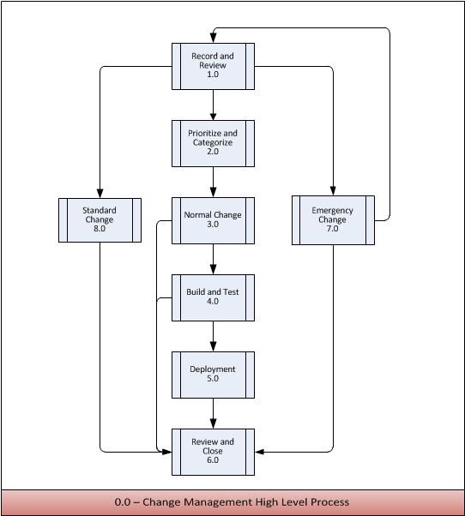

0.0 Change Management High Level Process Descriptions

Activity | Description
1.0  Record and Review | Information from the Request for Change (RFC) is used to create a Change record and allocate a unique identification number (in chronological sequence). Some information is recorded when the record is initiated and some may be added or updated through the change lifecycle. Though there may be different types of change records with different sets of attributes based on the change category, it is recommended to standardize wherever possible. The Change Manager will review and filter the Request for Change (RFC) according to the policies determined by the organization.
2.0  Prioritize and Categorize | Changes are categorized according to the type, size or risk of the change for the purposes of ensuring the correct level of oversight in assessing the change request. The greater the impact and/or higher the risk, the higher level of coordination is typically required.  Changes are prioritized to establish the order in which they should be put forward for consideration.
3.0  Normal Change | A normal change refers to changes that must follow the complete change management process. A Normal Change is reviewed by the OIT CAB. The OIT CAB will provide advice regarding the change to the Change Manager.
4.0  Build and Test | Authorized Changes should be passed to the relevant technical groups to build the Changes. Change Management has responsibility for ensuring that Changes are built and tested as scheduled. This is largely a coordination role, as the actual implementation will be the responsibility of the others.  Change Management has an oversight role to ensure that remediation procedures are prepared and documented in advance, that all Changes are thoroughly tested (where possible) and that implementation is scheduled when the least impact on live services is likely.
5.0  Deployment | Authorized Changes should be passed to the relevant technical groups to deploy the Changes. Change Management has responsibility for ensuring that Changes are built and tested as scheduled. This is largely a coordination role, as the actual implementation will be the responsibility of the others.
6.0  Review and Close | On completion of the Change implementation, the results should be reported for evaluation to the Change Manager and appropriate notifications made. Review should also include any Incidents arising as a result of the Change.  A Change Review (Post Implementation Review) should be carried out to confirm that the Change has met its objectives, that the initiator and stakeholders are happy with the results and that there have been no unexpected side-effects. Where a Change has not achieved its objectives, the Change Manager (and possibly the CAB) should decide what follow-up action is required.  If the review is satisfactory, the RFC should be formally closed in the logging system.
7.0  Emergency Change | An Emergency Change is a change that must be introduced as soon as possible; for example, to resolve a Major Incident or implement a critical security patch. The Change Management Process includes a specific procedure for handling Emergency Changes.
8.0  Standard Change | Standard Changes are changes that are repeatable, occur frequently, and are proven to be low risk. A pre-defined workflow will be established, approved by the CAB and subsequently followed. Approved Standard Changes are not reviewed by the CAB.

Record and Review Process

This section describes the Record and Review Process.

Record and Review Process Flow

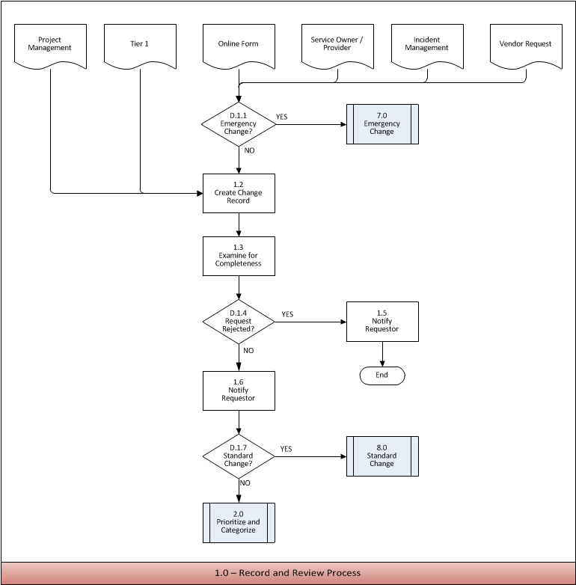

1.0 Record and Review Process Activity Descriptions

D.1.1 | Emergency Change?
Purpose | To determine if the Change is an Emergency. If the Change is an emergency, events will be handled by the separate Emergency Change Process
Decision Logic | Yes – Go to 8.0 Emergency Change Process  No – Go to 1.1 Create Change Record

1.2 | Create Change Record
Purpose | To ensure all Changes are appropriately recorded in the ITSM Tool.
Requirement  Statement | When recording a Change Record, it is the responsibility of Tier 1 to correctly complete all of the required information.
Input | Request for Change
Procedure or Work Instruction Steps | Open a Change Record using the ITSM tool. If record was already created in previous step (1.1), ensure the record contains the information below.  Reference RFC number as needed in departmental tracking system  Capture, at a minimum, the following information:  - Date  - Originator  - Change Requested  - Requested Completion Date  - Components Involved (if known)  - Reason For Change  - Link to any related prior or open RFC  - Perceived Impact (if change is made or not made)
Output | Change Record
Metric | Number of Change Records recorded per measurement period (e.g., weekly) compared to number of RFCs on file.  Number of RFCs linked to prior RFCs

1.3 | Examine for Completeness
Purpose | To ensure that the Change Record is complete and practical.
Requirement  Statement | When examining the Change Record, it is the responsibility of the Change Coordinator, Change Manager or Tier 1 to examine for completeness and practicality.
Input | Change Record
Procedure or Work Instruction Steps | - Examine the Change Record for completeness and practicality  - Assure that it is in compliance with Standards and Requirements  - Remediate information in Change Record if required  - Update the Change Record
Output | Updated Change Record
Metric

D.1.4 | Request Rejected?
Purpose | Decide if the Change is practical and determine if it should move forward.
Decision Logic | Yes – Go to 1.5 Notify Requester  No – Go to 1.6 Notify Requestor

1.5 | Notify Requestor
Purpose | To inform the Requestor that the RFC has been rejected.
Requirement  Statement | When advising the Requestor of the outcome of their RFC, it is the responsibility of the Change Coordinator, Change Manager and Tier 1 to provide them with the required information.
Input | Change Record
Procedure or Work Instruction Steps | - Contact the Requestor and inform them that their RFC has been rejected  - Note that an RFC will not be reopened. A new RFC must be submitted  - Update the Change Record
Output | Notification to Requestor  Updated Change Record
Metric | Number of rejected RFCs

1.6 | Notify Requestor
Purpose | To inform the Requestor that the RFC has been accepted.
Requirement  Statement | When advising the Requestor of the outcome of their RFC, it is the responsibility of the Change Coordinator, Change Manager and Tier 1 to provide them with the required information.
Input | Change Record
Procedure or Work Instruction Steps | - Contact the Requestor and inform them that their RFC has been accepted  - Change status of the Change Record to Accepted
Output | Notification to Requestor  Updated Change Record
Metric | Number of accepted RFCs

D.1.7 | Standard Change?
Purpose | To determine if this is a standard pre-approved change using the compiled list of standard pre-approved changes.
Decision Logic | Yes – Go to 8.0 Standard Change  No – Go to 2.0 Prioritize and Categorize

1.0 Record and Review Process RACI Matrix

An authority matrix is a tool used to help understand which parties need to be involved in changes and their level of involvement.

Process Roles  Activities Within Process | Change Mgmt  Process Owner | Change Manager | Change Coordinator | CAB | ECAB | Change Tester | Change Implementer | User | Tier 1
D.1.1 Emergency Change? | A | R/C
1.2 Create Change Record | A |  |  |  |  |  |  | C/I | R
1.3 Examine for Completeness | A | R/C/I | R/I |  |  |  |  | C | I
D.1.4 Request Rejected? | A | R/C | R/I |  |  |  |  |  | R/I
1.5 Notify Requestor | A | R/I | R/I |  |  |  |  | I | R/I
1.6 Notify Requestor | A | R/I | R/I |  |  |  |  | I | R/I
D.1.7 Standard Change? | A | R | R |  |  |  |  |  | R

Legend
A = Accountable | Accountable for final result
R = Responsible | Executes the task
C = Consulted | Consulted about the task to provide additional information
I = Informed | Needs to be kept up-to-date on activities/tasks

Prioritize and Categorize Process

This section describes the Record and Review Process.

2.0 Prioritize and Categorize Process Flow

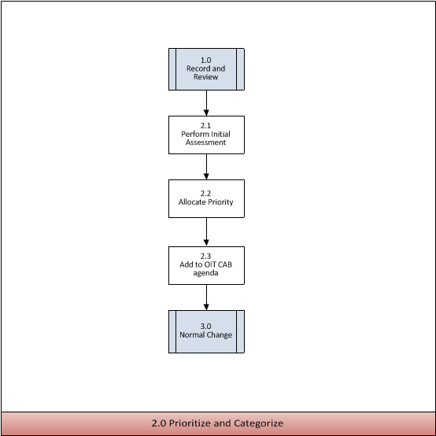

2.0 Prioritize and Categorize Process Activity Descriptions

2.1 | Perform Initial Assessment
Purpose | To ensure that all Changes are initially assessed based on impact.
Requirement Statement | When initially assessing the Change, it is the responsibility of the Change Manager and/or Change Coordinator to correctly assess the Change to determine the impact to the organization.
Input | Change Record
Procedure or Work Instruction Steps | - Clearly account for the impact to the organization that the Change will produce  - Record the information in the Change Record  - Update the Change Record
Output | Updated Change Record.
Metric

2.2 | Allocate Priority
Purpose | To ensure that all Changes are prioritized based on the Change Management Prioritization requirements.
Requirement Statement | When allocating priority to the Change, it is the responsibility of the Change Manager and/or Change Coordinator to correctly assess the priority.
Input | Change Record  Change Management Prioritization requirements
Procedure or Work Instruction Steps | - Review the impact and the urgency information from the Change Record  - Validate the priority against Prioritization Requirements.  - Determine if the initial priority is correct  - Update the priority on the Change Record  - Notify the Requestor of the change to priority  - Update the Change Record
Output | Updated Change Record
Metric | Number of changes by priority

2.3 | Add to OIT CAB Agenda
Purpose | To ensure that all approved Changes are included in the CAB meeting.
Requirement Statement | When including the Change in the next CAB meeting, it is the responsibility of the Change Manager and/or Change Coordinator to coordinate all Changes into the meeting for approval and to circulate the Changes to the CAB members prior to the meeting.
Input | Change Record
Procedure or Work Instruction Steps | - Change is circulated to all CAB members  - Change Record is updated  - Change is placed on the Agenda for the next OIT CAB meeting
Output | Updated CAB Agenda  Updated Change Record
Metric

2.0 Prioritize and Categorize Process RACI Matrix

An authority matrix is a tool used to help understand which parties need to be involved in changes and their level of involvement.

Process Roles  Activities Within Process | Change Mgmt Process Owner | Change Manager | Change Coordinator | CAB | ECAB | Change Tester | Change Implementer | User | Tier 1
2.1 Perform Initial Assessment | A | R/C | R |  |  |  | C | C
2.2 Allocate Priority | A | R | R |  |  |  |  | C/I
2.3 Add to CAB agenda | A | R | R | I

Legend
A = Accountable | Accountable for final result
R = Responsible | Executes the task
C = Consulted | Consulted about the task to provide additional information
I = Informed | Needs to be kept up-to-date on activities/tasks

Normal Change Process

This section describes the Normal Change Process.

3.0 Normal Change Process Flow

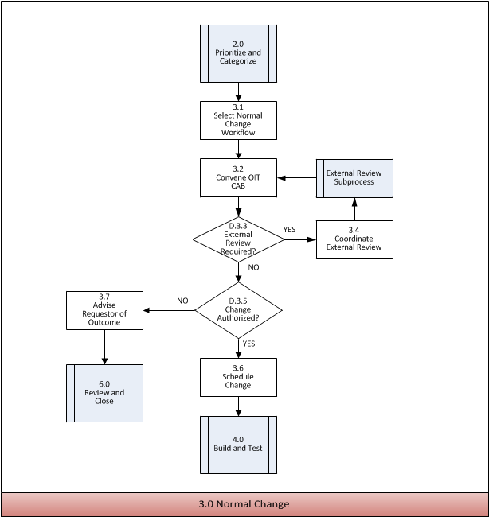

3.0 Normal Change Process Activity Descriptions

3.1 | Select Normal Change Workflow
Purpose | To ensure that the Change is set to follow the appropriate Change workflow.
Requirement Statement | When applying the Change workflow, it is the responsibility of the Change Manager or Change Coordinator to clearly define the appropriate Change workflow.
Input | Change record  Change workflows
Procedure or Work Instruction Steps | - Select the appropriate Change workflow  - Include Remediation Plan  - Include Testing Requirements  - Include Post Implementation review procedures  - Explanation of business benefits  - Resources and impact on current activities  - Update the Change Record
Output | Complete Change workflow  Updated Change Record
Metric | Number of changes by change workflow

3.2 | Convene OIT CAB
Purpose | To ensure that all significant changes are evaluated, assessed, prioritized and the appropriate change workflow has been selected.
Policy Statement | When conducting the OIT CAB, it is the responsibility of the Change Management Process Owner to build an agenda which includes all changes requiring consideration and to circulate the changes to the CAB members prior to the meeting.
Input | Change Record  Assessment of Change
Procedure or Work Instruction Steps | - The CAB will occur weekly  - CAB Members TBD  - Meeting will follow the predetermine agenda
Output | Updated Change Records
Metric

D.3.3 | External Review Required?
Purpose | Certain Changes may require the review of an external group prior to approval. This decision will determine if an external review is required.
Decision Logic | Yes – Go to 3.4 Coordinate External Review  No – Go to D.3.5 Change Authorized

3.4 | Coordinate External Review
Purpose | To coordinate external review
Policy Statement | When external review is required, it is the responsibility of the Change Manager, Change Coordinator to work with external review boards.
Input | Change Record  External Review Board requirements
Procedure or Work Instruction Steps | - Coordinate appropriately with external review board(s)  - Update the Change Record  - Notify the Customer and CAB of the result of the external review
Output | Updated Change Record  Notification sent to the Customer and CAB
Metric | Duration of external review

D.3.5 | Change Authorized?
Purpose | - To determine if the Change is authorized. If, for any reason, approving this Change as written will jeopardize the stability or quality of customer products or services, the Change should be rejected with an appropriate explanation. Otherwise, the Change should be authorized
Decision Logic | Yes – Go to 3.6 Schedule Change  No – Go to 3.7 Advise Requestor of Outcome

3.6 | Schedule Change
Purpose | To schedule the Change.
Requirement Statement | When scheduling the Change, it is the responsibility of the Change Coordinator, Change Manager to ensure that there are no conflicts with other scheduled Changes and to notify the Requestor of the scheduled Change.
Input | Change Record  Change Schedule
Procedure or Work Instruction Steps | - Schedule the official production date for the Change  - Update the Change Schedule  - Update the Change Record  - Notify the Requestor of the scheduled Change
Output | Updated Change Schedule  Updated Change Record  Notification sent to the Requestor
Metric

3.7 | Advise Requestor of Outcome
Purpose | To inform the Requestor that the Change was not authorized.
Requirement  Statement | When advising the Requestor of the outcome of their RFC, it is the responsibility of the Change Coordinator, Change Manager to provide them with the required information.
Input | Change Record
Procedure or Work Instruction Steps | - Contact the Requestor and inform them that the change was not authorized  - Provide details surrounding the decision
Output | Notification to Requestor  Updated Change Record
Metric

3.0 Normal Change Process RACI Matrix

An authority matrix is a tool used to help understand which parties need to be involved in changes and their level of involvement.

Process Roles  Activities Within Process | Change Mgmt Process Owner | Change Manager | Change Coordinator | CAB | ECAB | Change Tester | Change Implementer | User | Tier 1
3.1 Select Normal Change workflow | A | R/C | R/C | I
3.2 Convene OIT CAB | A/R | C/I | I | C/I
D.3.3 External review required? | A |  |  | R
3.4 Coordinate external review | A | R | R | I |  |  |  | C/I
D.3.5 Change authorized? | A | R | I | C/I
3.6 Schedule Change | A | R/C/I | R/C/I | I |  | C/I | C/I | C/I | I
3.7 Advise Requestor of Outcome | A/R | C/I | I | C/I

Legend
A = Accountable | Accountable for final result
R = Responsible | Executes the task
C = Consulted | Consulted about the task to provide additional information
I = Informed | Needs to be kept up-to-date on activities/tasks

Build and Test Process

This section describes the Build and Test Process.

4.0 Build and Test Process Flow

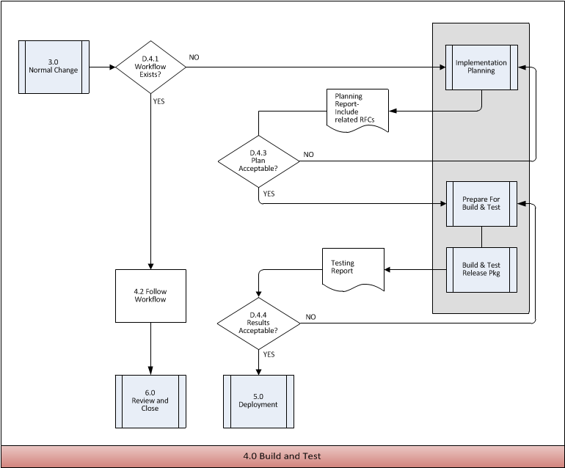

4.0 Build and Test Process Activity Descriptions

4.1 | Workflow Exists?
Purpose | To determine if a workflow already exists for this change
Requirement Statement | When preparing for build and test, it is the responsibility of the Change Coordinator, Change Manager to determine if a relevant workflow already exists.
Input | Change record  List of Change workflows
Procedure or Work Instruction Steps | - To assess requirements for the change to determine if there is a matching workflow  - If yes, go to 4.2  - If no, go to Implementation Planning sub-process  - Update Change Record with workflow selected
Output | Updated Change Record  Decision
Metric | Number of changes without existing Change workflow

4.2 | Follow Workflow
Purpose | To ensure that build and test for each Change is executed according to plan
Requirement Statement | When coordinating the Change process, it is the responsibility of the Change Implementer, Change Tester to ensure that the workflow is being followed appropriately.
Input | Selected Change workflow  Change Record
Procedure or Work Instruction Steps | - Follow the Change workflow previously selected including deployment
Output | Change workflow and associated tasks, Implementation Plan, Testing Plan, Deployment Report
Metric

D.4.3 | Is the Plan Acceptable?
Purpose | To ensure that the Plan produced for deploying the Change is acceptable.
Decision Logic | Yes – Go to Prepare for Build and Test Activities  No – Return to Implementation Planning Activities

D.4.4 | Are Test Results Acceptable?
Purpose | To determine if the test results were acceptable.
Decision Logic | Yes – Go to 5.0 Deployment  No – Return to Build and Test Activities

4.0 Build and Test Process RACI Matrix

An authority matrix is a tool used to help understand which parties need to be involved in changes and their level of involvement.

Process Roles  Activities Within Process | Change Mgmt Process Owner | Change Manager | Change Coordinator | CAB | ECAB | Change Tester | Change Implementer | User | Tier 1
D.4.1 Workflow Exists? | A | R | R |  |  | I | I
4.2 Follow Workflow | A | I | I |  |  | R | R
D.4.3 Plan Acceptable? | A | R |  | R |  |  | C/I
D.4.4 Results Acceptable? | A | R |  | R |  | C/I | I | I

Legend
A = Accountable | Accountable for final result
R = Responsible | Executes the task
C = Consulted | Consulted about the task to provide additional information
I = Informed | Needs to be kept up-to-date on activities/tasks

Deployment Process

This section describes the Deployment Process.

5.0 Deployment Process Flow

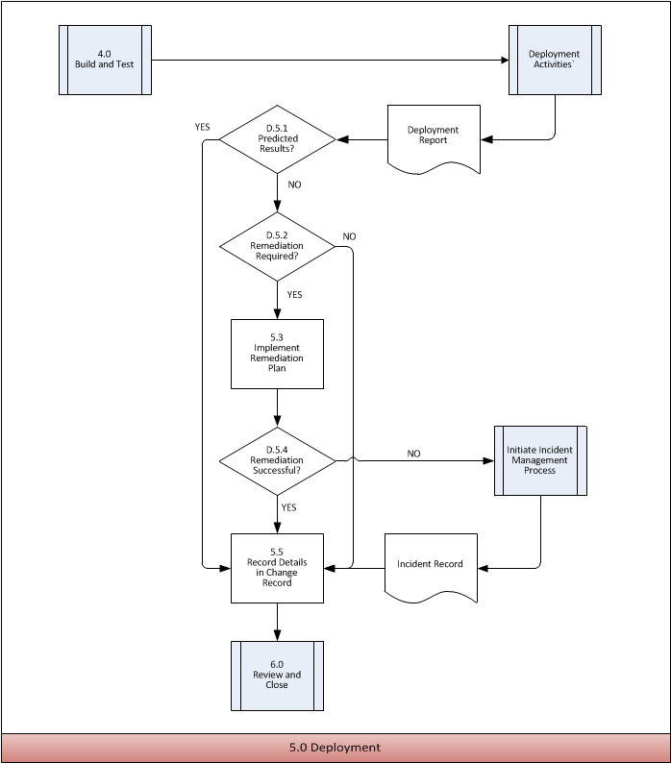

5.0 Deployment Process Activity Descriptions

D.5.1 | Predicted Results?
Purpose | To determine if the Change produced predicted results. Deployment report is reviewed and compared against expected results.
Decision Logic | Yes – Go to 5.5 Record Details in Change Record  No – Go to D.5.2 Remediation Required?

D.5.2 | Remediation Required?
Purpose | To determine if the Remediation Plan should be implemented. All remediation plans will define the circumstances that will require remediation and who may authorize it.
Decision Logic | Yes – Go to 5.3 Implement Remediation Plan  No – Go to 5.5 Record Details in Change Record

5.3 | Implement Remediation Plan
Purpose | To ensure that recovery to the known state before the implementation can be restored.
Requirement Statement | When implementing the Remediation Plan, it is the responsibility of the Change Implementer to implement the Remediation Plan.
Input | Remediation plan  Failed Change
Procedure or Work Instruction Steps | - Follow pre-defined Remediation Plan
Output | Tasks as defined in Remediation Plan
Metric | Number of implemented Remediation Plans

D.5.4 | Remediation Successful?
Purpose | To determine if remediation was successful. If production environment is not restored, open an incident record and report Remediation Plan as failed. Continue to work to resolve under guidance of Incident Management Process. This is especially important if the Change has exceeded the scheduled implementation window.
Decision Logic | Yes – Go to 5.5 Record Details in Change Record  No – Go to Initiate Incident Management Process

5.5 | Record Details In Change Record
Purpose | After Change is deployed, full documentation is provided in the Change Record
Requirement Statement | It is the responsibility of the Change Implementer to fully document the details of the Change, its success or failure, the decision to remediate and the exact steps taken to remediate if the change failed.
Input | Incident Record (if needed)  Change Record
Procedure or Work Instruction Steps | - Fully document the details of the Change deployment  - Document the success, failure and/or any anomalies  - Record any deviations from the documented deployment plan  - Record the exact steps taken if remediation was necessary and associate to any related Incident Management records
Output | Updated Change Record
Metric | Number of failed remediation(s) with associated Incident Records

5.0 Deployment Process RACI Matrix

An authority matrix is a tool used to help understand which parties need to be involved in changes and their level of involvement.

Process Roles  Activities Within Process | Change Mgmt Process Owner | Change Manager | Change Coordinator | CAB | ECAB | Change Tester | Change Implementer | User | Tier 1
D.5.1 Predicted Results? | A | R | C/I | R |  | C | C/I | C
D.5.2 Remediation Required? | A | R/C | R/C |  |  | C | C | C
5.3 Implement Remediation Plan | A | C/I | C/I |  |  | C | R
D.5.4 Remediation Successful? | A | R/C | R/C | I |  | C | C | C
5.5 Record Details in Change Record | A | C/I | C/I | I |  |  | R |  | I

Legend
A = Accountable | Accountable for final result
R = Responsible | Executes the task
C = Consulted | Consulted about the task to provide additional information
I = Informed | Needs to be kept up-to-date on activities/tasks

Review and Close Process

This section describes the Review and Close Process.

6.0 Review and Close Process Flow

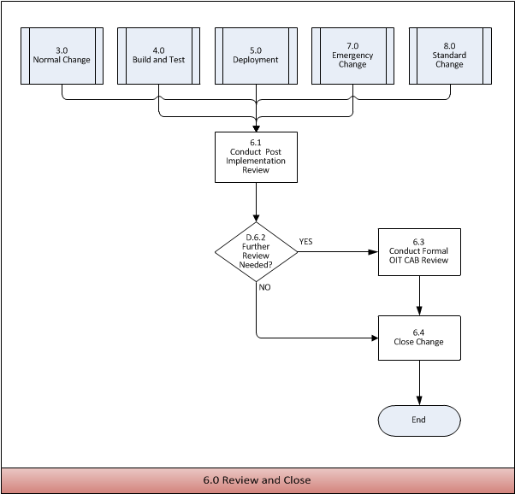

6.0 Review and Close Process Activity Descriptions

6.1 | Conduct Post-Implementation Review
Purpose | To ensure that a Post Implementation Review (PIR) is conducted following the implementation of a Change.
Requirement  Statement | When a Change has been implemented, it is the responsibility of the Change Implementer and CAB in collaboration with all stakeholders to ensure that a Post Implementation Review is conducted following the implementation or as specified in the RFC.
Input | Change results  Release & Deployment results  Approved Change  Requirements and expectations for the Change  Incidents related to the Change  Problems and known errors related to the Change
Procedure or Work Instruction Steps | - Following implementation or designated time assemble PIR Review Board to review the changes  - Review the Change results and compare them to the RFC, e.g.:  - Were objectives/expectations met?  - Were there any unexpected, undesirable side-effects?  - Were the resources used to implement the Change as planned?  - Were user requirements met?  - Identify what parts of the Change went well  - If there were any deviations, determine what impact (positive or negative) they had on the Change. Should these deviations be added to the formal process if beneficial or documented as being not allowed if negative?  - Update the Record
Output | Updated Change Record
Metric

D.6.2 | Further Review Needed?
Purpose | To determine if a formal Post Implementation Review with report is called for.
Decision Logic | Yes – Go to 6.3 Conduct Formal OIT CAB Review  No – Go to 6.4 Close Change

6.3 | Conduct Formal OIT CAB Review
Purpose | To ensure that the required actions are documented and the required people are informed.
Requirement Statement | When a Changes identified for Formal PIR have been identified, it is the responsibility of the Change Initiator, Change Coordinator and Change Manage to convene a Formal Post Implementation Review
Input | Initial Review results  Change Evaluation (if Major)  Updated RFC with implementation detail
Procedure or Work Instruction Steps | - In those cases where the change has not met its objectives or that the initiator and stakeholders are unsatisfied with the results:  - Identify any steps in the process or parts of the RFC that may have led to the failure of the change. Review any Root Cause Analysis reports from any Problems that were created by this RFC.  - Identify issues to determine what actions could be taken to prevent them from recurring in the future.  - Assign any action items to appropriate owners. Notify those owners of the actions and target date assigned to them  - Document action items and all discussion points for publication in the PIR Report  - Review Change Evaluation as available if a Major Change  - Publish the PIR Report  - Associate the PIR Report to the RFC. If there were any Incidents or Problems that were related to this Change, associate them to the RFC as well  - Update the RFC/Change Log/Change Record
Output | Updated Change Log/Change Record  Published PIR Report
Metric

6.4 | Close Change
Purpose | To ensure that the Change is closed once all activities have been completed.
Requirement Statement | When the Change is closing, it is the responsibility of the Change Initiator, Change Coordinator and Change Manager to ensure that all activities concerning the Change have been completed and documented.
Input | Completed, Reviewed RFC  Rejected RFC
Procedure or Work Instruction Steps | - Finalize the RFC  - Update the RFC with any remaining information and update the status to Closed  - Update the Change Log with the appropriate information  - Send notification to the Requestor that the RFC has been closed
Output | Closed RFC  Notification of closure  Updated Change Log
Metric

6.0 Review and Close Process RACI Matrix

An authority matrix is a tool used to help understand which parties need to be involved in changes and their level of involvement.

Process Roles  Activities Within Process | Change Mgmt Process Owner | Change Manager | Change Coordinator | CAB | ECAB | Change Tester | Change Implementer | User | Tier 1
6.1 Conduct Post-Implementation Review | A | R/C/I | R/C/I |  |  | C | R/C | C | C
D.6.2 Further Review Needed? | A | R/C/I | R/C/I |  |  |  | R/C
6.3 Conduct Formal OIT CAB Review | A | C | C | R |  | C | C | C | C
6.4 Close Change | A | R/C/I | R/C/I | I |  |  | R/C/I | I | I

Legend
A = Accountable | Accountable for final result
R = Responsible | Executes the task
C = Consulted | Consulted about the task to provide additional information
I = Informed | Needs to be kept up-to-date on activities/tasks

Emergency Change Process

This section describes the Emergency Change Process.

7.0 Emergency Change Process Flow

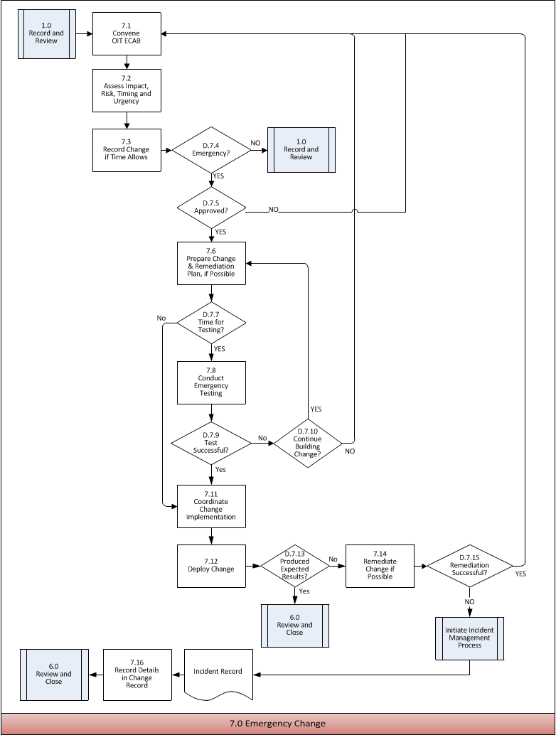

7.0 Emergency Change Process Activity Descriptions

7.1 | Convene OIT ECAB
Purpose | To convene the OIT ECAB to ensure the correct interests are represented in the coordination of an Emergency Change.
Policy Statement | When convening an ECAB meeting, it is the responsibility of the Change Manager and Change Coordinator to assemble the ECAB.
Input | All available information about the Emergency Change
Procedure or Work Instruction Steps | In most cases, the ECAB is a dynamic coordination effort consisting of those people who are involved in the effort to restore service during an outage. The member may include but are not limited to:  - Change Manager  - Service Owner  - Service Provider  - Change Implementer  - Dependent Service Techs and Managers
Output | ECAB
Metric

7.2 | Assess Impact, Risk, Timing and Urgency
Purpose | To ensure that the Change is assessed quickly in order to begin the required Change and restore normal service as soon as possible.
Policy Statement | When assessing the Change, it is the responsibility of the ECAB to assess the impact, risk , urgency and timing of the Change in order to make an informed decision.
Input | All available information about the Emergency Change
Procedure or Work Instruction Steps | - ECAB member will discuss the urgency of the Change based on the impact, resources and urgency  - The scheduled implementation of the change will be discussed
Output | Assessment of the urgency and scheduling of the Change
Metric

7.3 | Record Change when Time Allows
Purpose | To ensure all Emergency Changes are appropriately recorded in the ITSM Tool.
Policy Statement | When recording a Change Record from a Request for Change, it is the responsibility of the Change Manager to correctly complete all of the required information. This step may be completed in retrospect if there is no time for documentation.
Input | All available information about the Emergency Change  ECAB Assessment
Procedure or Work Instruction Steps | Open a Change Record  Capture, at a minimum, the following information:  - Date  - Originator  - Change Requested  - Reason for Emergency processing  - Perceived Impact  The Change Request can be documented in retrospect when there is no time for documentation.
Output | Change Record
Metric | Number of Emergency Changes

D.7.4 | Emergency?
Purpose | To make a final decision in determining if the change should proceed as an Emergency Change
Decision Logic | Yes- Go to D.7.5 Approved  No – Return to normal change process

D.7.5 | Approved?
Purpose | ECAB will make a final decision in determining whether the Emergency Change should move forward.
Decision Logic | Yes- Go to D.7.6 Prepare Change & Remediation Plan if Possible  No – Return to normal change process

7.6 | Prepare Change & Remediation Plan, If Possible
Purpose | To create the Change and if possible, create a remediation plan.
Policy Statement | When preparing the Change and back-out plan, it is the responsibility of the Change Coordinator, Change Manager to develop the Change and back-out plan.
Input | Change Record or Approved Emergency Change
Procedure or Work Instruction Steps | - Prepare the Change  - Develop a back-out plan given the time required  - Update the Change Record
Output | Updated Change Record
Metric

7.7 | Time For Testing?
Purpose | To determine if there’s enough time for testing. The Changer Manager will gauge the impact, urgency and risk of the Change in order to define the time required for testing.
Decision Logic | Yes- Go to 7.8 Conduct Emergency Testing  No – Go to 7.11 Coordinate Change Implementation

7.8 | Conducting Emergency Testing
Purpose | To ensure that testing has occurred before implementing the Change; if not, implement regression testing following implementation.
Requirement Statement | When conducting testing, it is the responsibility of the Change Tester to ensure that testing occurs before or after the Change has been implemented.
Input | Change Record or Approved Emergency Change  Testing plan
Procedure or Work Instruction Steps | - Gather all necessary testing information required to perform the testing and document in the Change Record  - Execute testing according to plan  - Update Change Record
Output | Test results  Updated Change Record
Metric

D.7.9 | Test Successful?
Purpose | To determine the success of the test.
Decision Logic | Yes – Go to 7.11 Coordinate Change Implementation  No – Go to D.7.10 Continue Building Change?

D.7.10 | Continue Building Change?
Purpose | To determine if the Emergency Change should continue being built in the event of an unsuccessful test.
Decision Logic | Yes – Go to 7.6 Prepare Change & Remediation Plan, if Possible  No – Go to D.7.1 Convene OIT CAB

7.11 | Coordinate Change Implementation
Purpose | To ensure that the Emergency Change can be implemented at a reasonable time given the circumstances.
Requirement Statement | When implementing an Emergency Change, it is the responsibility of the Change Coordinator to coordinate the Change without impacting the business and without conflict with other Changes in the Change Schedule.
Input | Change Record or Approved Emergency Change  Test Results
Procedure or Work Instruction Steps | - Verify no conflicting changes on schedule  - Resolve any conflict based on Priority of all conflicting changes  - Attempt to identify new target dates if conflicts occur, given the urgency of the Change  - Schedule an official production date and update the Change Schedule.  - Update the Change Record
Output | Updated Change Schedule  Updated Change Record
Metric

7.12 | Deploy Change
Purpose | To implement the Emergency Change using all the available information. Deployment will be consistent with the plan and schedule.
Requirement Statement | When implementing the Emergency Change, it is the responsibility of the Change Implementer to execute the implementation as planned.
Input | Change Record or Approved Emergency Change  Change Schedule
Procedure or Work Instruction Steps | - Check Change Schedule to ensure planning is correct  - Ensure that resources are available  - Deploy Change  - Update Change Record
Output | Updated Change Record
Metric

D.7.13 | Produced Expected Results?
Purpose | To ensure that the Emergency Change that was implemented produced the expected results as defined.
Decision Logic | Yes – Go to 7.16 Record Details in Change Record  No – Go to 7.14 Remediate Change if Possible

7.14 | Implement Remediation Plan if Possible
Purpose | To recover to the known state before the implementation of the Change.
Requirement Statement | When implementing the Remediation Plan, it is the responsibility of the Change Implementer to ensure that the back-out plan is viable and can be implemented immediately following a failure or when required.
Input | Remediation Plan  Change Record
Procedure or Work Instruction Steps | - Notification is received that a failure occurred  - Research if the Emergency Change should be installed again if there’s time  - If not, execute the Remediation Plan to restore the production environment to the previous state  - Validate the restored environment  - If production environment is not restored, open an Incident Record and report Remediation Plan failed. Continue to work to resolve under guidance of Incident Management Process. This is especially important if the Change has exceeded the scheduled implementation window  - Update Change Record
Output | Updated Change Record  Incident Ticket (if required)
Metric

D.7.15 | Remediation Successful?
Purpose | To determine if the Incident Management process needs to be initiated or whether the change needs to be brought back to the OIT ECAB.
Decision Logic | Yes – Go to 7.1 Convene OIT CAB  No – Go to Initiate Incident Management Process

7.16 | Record Details In Change Record
Purpose | After Change is deployed, full documentation is provided in the Change Record
Requirement Statement | It is the responsibility of the Change Implementer to fully document the details of the Change, its success or failure, the decision to remediate and the exact steps taken to remediate if the change failed.
Input | Incident Record (if needed)  Change Record
Procedure or Work Instruction Steps | - Fully document the details of the remediation  - Document the success, failure and/or any anomalies  - Record any deviations from the documented remediation plan  - Associate to any related Incident Management records
Output | Updated Change Record
Metric | Number of failed remediation(s) with associated Incident Records

7.0 Emergency Change Process RACI Matrix

An authority matrix is a tool used to help understand which parties need to be involved in changes and their level of involvement.

Process Roles  Activities Within Process | Change Mgmt Process Owner | Change Manager | Change Coordinator | CAB | ECAB | Change Tester | Change Implementer | User | Tier 1
7.1 Convene OIT ECAB | A | R | R/C/I |  | C | C | C | I | I
7.2 Assess Impact, Risk, Timing, and Urgency | A | R | R/C |  | C | C | C | C | I
7.3 Record Change if Time Allows | A | R | C |  |  |  |  |  | C/I
D.7.4 Emergency? | A | R | C |  |  |  | C | C | I
D.7.5 Approved? | A | R | C |  |  |  | I | I | I
7.6 Prepare Change & Remediation Plan, if Possible | A | R | C |  |  | C/I | C/I |  | I
D.7.7 Time for Testing? | A | R | C |  |  | C | C |  | I
7.8 Conduct Emergency Testing | A | C | C |  |  | R | C |  | I
D.7.9 Test successful? | A | R | C |  |  | C |  |  | I
D.7.10 Continue Building Change? | A | R | C |  |  | C | C | C/I | I
7.11 Coordinate Change Implementation | A | C | R |  |  |  | C | I | I
7.12 Deploy Change | A | C | C |  |  |  | R | I | I
D.7.13 Produced Expected Results? | A | R | C |  |  |  | C |  | I
7.14 Remediate Change if possible | A | C | C |  |  |  | R |  | I
D.7.15 Remediation Successful? | A | R | C |  |  |  |  | C | I
7.16 Record Details in Change Record | A |  |  |  |  |  | R

Legend
A = Accountable | Accountable for final result
R = Responsible | Executes the task
C = Consulted | Consulted about the task to provide additional information
I = Informed | Needs to be kept up-to-date on activities/tasks

Standard Change Process

This section describes the Standard Change Process.

8.0 Standard Change Process Flow

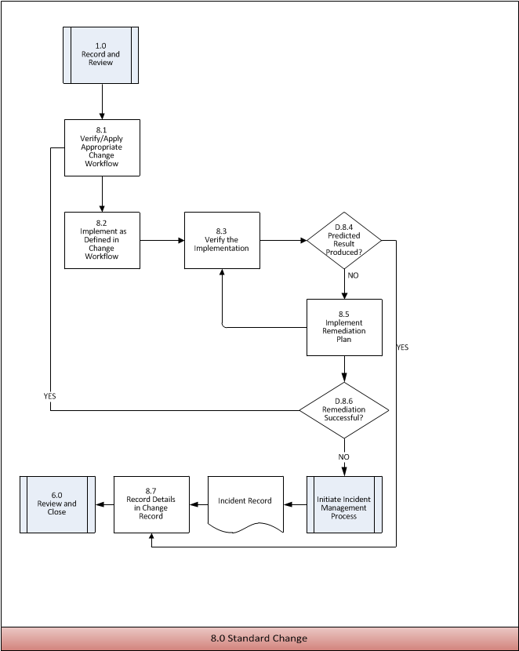

8.0 Standard Change Process Activity Descriptions

8.1 | Verify/Apply Appropriate Change Workflow
Purpose | To ensure the appropriate Change workflow is applied.
Requirement Statement | When applying the Change Workflow, it is the responsibility of the Change Coordinator and/or Change Implementer to verify appropriate Change workflow is being used before moving forward with approval.
Input | List of Change Workflows  Change Record
Procedure or Work Instruction Steps | - Review the list of Change workflows.  - Ensure the appropriate Change Workflow is applied.  - Update the Change Record.
Output | Updated Change Record
Metric

8.2 | Implement as Defined in Change Workflow
Purpose | To ensure the Standard Change is implemented in accordance with the approved Change workflow.
Policy Statement | When implementing a Standard Change it is the responsibility of the Change Implementer to follow the flow as defined in the previously approved Change workflow.
Input | Change Record  Change workflow
Procedure or Work Instruction Steps | - Follow the Change workflow to implement the Change.  - Update the Change Record.
Output | Updated Change Record
Metric

8.3 | Verify the Implementation
Purpose | To ensure the change produced the expected results.
Requirement Statement | When verifying the implementation, it is the responsibility of the Change Implementer and/or Change Tester to ensure the implementation produced the expected results.
Input | Change Record  Change Workflow
Procedure or Work Instruction Steps | - Verify that the Change produced the expected results as defined in the pre-approved Change workflow  - Update the Change Record
Output | Updated Change Record
Metric | Number of successful and/or unsuccessful Standard Changes

D.8.4 | Predicted Result Produced?
Purpose | To determine if the change produced the predicted results.
Decision Logic | Yes – Go to 8.7 Record Details in Change Record  No – Go to 8.5 Implement Remediation Plan

8.5 | Implement Remediation Plan
Purpose | To recover to the known state before the implementation of the Change.
Requirement Statement | When implementing the Remediation Plan, it is the responsibility of the Change Implementer to ensure that the remediation plan is implemented immediately following a failure or when required.
Input | Remediation Plan  Change Record
Procedure or Work Instruction Steps | - Execute the Remediation Plan to restore the production environment to the previous state  - Validate the restored environment  - If production environment is not restored, open an Incident Record and report Remediation Plan failed. Continue to work to resolve under guidance of Incident Management Process. This is especially important if the Change has exceeded the scheduled implementation window  - Update Change Record
Output | Updated Change Record  Incident Ticket (if required)
Metric

D.8.6 | Remediation Successful?
Purpose | To determine if the Incident Management process needs to be initiated
Decision Logic | Yes – Go to 8.1 Verify / Apply Appropriate Change Workflow  No – Initiate Incident Management process and record details in change record

8.7 | Record Details in Change Record
Purpose | After a Standard Change is deployed, full documentation is provided in the Change Record
Requirement Statement | It is the responsibility of the Change Implementer to fully document the details of the Change, its success or failure, the decision to remediate and the exact steps taken to remediate if the change failed.
Input | Incident Record (if needed)  Change Record
Procedure or Work Instruction Steps | - Fully document the details of the Standard Change deployment  - Document the success, failure and/or any anomalies  - Record any deviations from the documented Standard Change Workflow  - Record the exact steps taken if remediation was necessary and associate to any related Incident Management records
Output | Updated Change Record
Metric | Number of failed remediation(s) with associated Incident Records

8.0 Standard Change Process RACI Matrix

An authority matrix is a tool used to help understand which parties need to be involved in changes and their level of involvement.

Process Roles  Activities Within Process | Change Mgmt Process Owner | Change Manager | Change Coordinator | CAB | ECAB | Change Tester | Change Implementer | User | Tier 1
8.1 Verify/Apply Appropriate Change workflow | A | C | R |  |  |  | R
8.2 Implement as Defined in Change workflow | A | C/I | C |  |  |  | R
8.3 Verify Implementation | A | C/I | C/I |  |  | R | R
D.8.4 Predicted Results Produced? | A | C/I | C/I |  |  | R | R |  | I
8.5 Impliment Remediation Plan | A |  |  |  |  |  | R
D.8.6 Remediation Successful? | A | C/I | C/I |  |  |  | R |  | I
8.7 Record Details in Change Record | A | C/I | C/I |  |  |  | R |  | I

Legend
A = Accountable | Accountable for final result
R = Responsible | Executes the task
C = Consulted | Consulted about the task to provide additional information
I = Informed | Needs to be kept up-to-date on activities/tasks

Process Performance Reports

This section describes the Change Management reports as recommended for {organization name} line management. Only an overview of the reports, including their use and objective, is provided in the main body of this section.

A distinction is made between Senior Management, Middle Management and Section Manager. Additionally, process performance reports for process staff are described in this section for the Change Management Process Owner, Change Management Process Manager, and Change Management Process Analyst.

These are living documents and require periodic re-examination and refinement of the Critical Success Factors (CSFs) and Key Performance Indicators (KPIs) as the process matures.

Senior Management Reports

Senior Management Reports are generated for Chief Information Technology Office Staff. They provide information to managers on the quality and performance of the Change Management process and to identify areas for improvement.

Report Structure

Contents | Accountable For Production
This report is a formal document and is subject to document control. The following structure is recommended:  - Management Summary  - Performance against CSFs  - Analysis of KPIs metrics  - Specific CSFs included in this report are identified in the Management Report / Critical Success Factor Mapping Table  - Change Management issues requiring Senior Management action with a crisp description of the requested action | Change Management Process Owner
- Frequency | Monthly

Middle Management Report

Middle Management reports are generated for the Departmental Managers. The reports contain more detail as compared to the Senior Management reports. The general objective of these reports is to steer the more operational aspects of Change Management.

Report Structure

Contents | Accountable For Production
This report is a formal document and is subject to document control. All report data will be focused on departmental teams. The following structure is recommended:  - Management Summary  - Performance against CSFs  - Analysis of KPIs metrics  - Specific CSFs included in this report are identified in the Management Report / Critical Success Factor Mapping Table | Change Management Process Owner
- Frequency | Monthly

Stakeholder Reports

Stakeholder reports are generated for the service areas. The reports contain more detail as compared to the Senior Management reports. The general objective of these reports is to steer the more operational aspects of Change Management.

Report Structure

Contents | Accountable For Production
This report is a formal document and is subject to document control. All report data will be focused on service areas. The following structure is recommended:  - Management Summary  - Performance against CSFs  - Analysis of KPIs metrics  - Specific CSFs included in this report are identified in the Management Report / Critical Success Factor Mapping Table | Change Management Process Owner
- Frequency | Monthly

Critical Success Factors and Key Performance Indicators

Numbers | CSFs | KPIs | Sources | Calculation Interval
1 | Reduced adverse impact of Changes on the business
1.1 |  | Percentage decrease in Incidents related to Changes | ITSM Tool for Incidents and Changes | Monthly
1.2 |  | Percentage decrease in work effort after the Change | ITSM Tool | Monthly
1.3 |  | Customer satisfaction survey after a Change occurs targeting the specific user community affected by the Change | Survey Monkey, Google Forms, etc. | Monthly
2 | Changes implemented in a timely manner
2.1 |  | Amount of time expected to complete a Change versus the amount of time it actually took to complete the Change | Standard Change workflows including a predetermined amount of time to complete the Change- ITSM Tool | Monthly
2.2 |  | Average time by status and category to complete a Change i.e. Standard Change- open/close, Normal Change- open/close, Emergency Change | ITSM Tool | Monthly
2.3 |  | Number of Changes rescheduled versus the number of changes meeting a schedule | ITSM Tool | Monthly
3 | Improved communication and collaboration internally and externally
3.1 |  | Customer satisfaction survey after a Change occurs targeting the specific user community affected by the Change. Internal surveys are included to collect the level of satisfaction throughout OIT | Survey Monkey, Google Forms, etc. | Monthly
3.2 |  | Number of add, remove and changes to the OIT Change Calendar | OIT Change Calendar | Monthly
3.3 |  | Post implementation review to include lessons learned and whether a workflow needs to be modified | CAB meeting notes and ITSM Tool | Monthly

Change Types Explained

Standard Change

OIT Standard Change Requirements:
In order to be classified as a Standard Change the change must be approved by the OIT Change Advisory
Board (CAB). All Standard Changes will be reviewed by the OIT CAB annually to ensure they are still
valid.

The following is required when submitting a change to be an OIT Standard Change:
• This change is scriptable (step by step work procedures) and successfully repeatable
• This has been proven to be a low impact change
• Documented build procedures exist
• Test change and document results
• Install plan (time to install, steps required) documented
• Applicable customer, user, and internal notifications/communications are built into the workflow
• Link procedural documentation for execution to each Standard Change Request (link to template)
• Back-out or Recovery procedure is documented and tested

Normal Change

OIT Major/Minor Change Requirements:
A Major/Minor Change is not a Standard Change, or an Emergency Change. It follows a pre-defined
workflow within the Change Management process. It is divided into two categories, which are evaluated
according to the impacts, risks, benefits, and costs. A Major Change requires approval from the OIT CAB.
A Minor Change may be authorized by the relevant Change Manager.

By definition, a Minor Change is low risk, low impact, and low complexity. Frequently implemented
Minor Changes are candidates to become Standard Changes.

Emergency Change

OIT Emergency Change Requirements:
In order to be classified as an Emergency Change, the change must be approved by the OIT Emergency
Change Advisory Board (ECAB). Any actual/potential service interruption or security breach that is classed
as high impact, either on account of the number of users affected or because systems or services that are
critical to the organization are involved, must be responded to immediately. The resolution or prevention of
the interruption frequently requires a change, and has to be carried out following emergency procedures.
The ECAB is a dynamically convened consisting of those people who are involved in the effort to prevent service interruption or restore service during an outage. The membership may include but is not limited to:
• Change Manager
• Service Owner
• Service Provider
• Change Implementer
• Dependent Service Techs and Managers
• Vendors

The following is required when submitting a change to be an OIT Emergency Change:
• Existence of an Incident record, meeting the above criteria
• All available information supporting rationale for Emergency Change
• Description of proposed Change

OIT Change Advisory Board (CAB)

CAB Procedures

- OIT CAB meetings will be held weekly on Wednesday mornings.
- The Change Manager / Process Owner Chairs the meeting .
- Minutes will be taken by student interns or rotated amongst the Change Managers
  - All minutes will be sent out via email in advance of the next meeting. Those who do not reply with modifications to the minutes are approving the minutes by default.
- Agenda preparation will be completed by the Change Management Process Owner with the assistance of the Project Management Office (PMO).
- All Normal Changes will be logged on the OIT Change Calendar. Change Managers will invite the OIT Change Calendar when adding Changes to their departmental calendar.
  - Level of detail- The calendar invite will include the link to the Activity/Outage Notice. When filling out the Activity/Outage Notice, ensure to select whether the notice is DRAFT, PRE-CAB, POST-CAB, or DISTRIBUTED and adjust the notice as it goes through the CAB process.
  - Changes will be added to the OIT Change Calendar at the same time the Activity/Outage Notice is filled out.
  - Subject line in the OIT Calendar Invite will make use of code words to identify all Changes: 1. Outage 2. Activity 3. Emergency Activity 4. Emergency Outage. Separated by a colon, after identifying the Change, identification of the status is required: Completed, update, canceled. EXAMPLE- Outage: Completed.
  - Outage/Activity Notices will be submitted for all Normal Changes 72 hours before implementation.
- Date for submission of Request for Change (RFC)- In order to be on the agenda for that week’s CAB meeting, RFCs must be submitted by Monday at noon, allowing Change Managers a little over 24 hours to review the changes and agenda.
- Proxies will be allowed, only if they have the authority to make decisions affecting the Change.
- Standing agendas will be used with reports that are generated directly from the ITSM Tool to avoid agenda preparation time. The tool may also be used to document notes.
- The Change Manager in charge of the department affected by a RFC will be responsible for notifying the submitter that a RFC has been rejected by the OIT CAB.
- Justification for the decision will be documented in the Change Record.

ECAB Procedures

- ECABs are dynamically convened, consisting of those people who are involved in the effort to prevent service interruption or restore service during an outage.
- The ECAB must include at least one relevant Change Manager and can include, but are not limited to Subject Matter Experts, Service Owners, Service Provider, Process Owners, Change Implementer, business representatives, Distriputed Service Techs and vendors.
- It is understood that documentation of the Emergency Change will occur prior to implementing the Change, unless the situation dictates otherwise, including adding the Change to the Change Schedule.
  - If it is not possible to document the Change before implementation, documentation will be completed as soon as possible and no later than 24 hours after the Change.
- All Emergency Changes will be reviewed at the next OIT CAB meeting
- When possible, the Support Center shall be informed of the status of the event in order to publish Outage Notices and updated status information
- The Support Center will be informed at the time of resolution

OIT CAB External Review

- External review will be triggered from within 3.0- Normal Change
- External Review Criteria:
  - Need Functional User Approval for Schedule
  - Need Functional User Approval for Requests from other users (i.e. SRC request for HR Data)
  - Need higher level approval (Director/CITO/etc)- conflicts the CAB is unable to resolve
  - Any change impacting a MAU campus
- External Review Examples include but are not limited to:
  - University of Alaska Anchorage Change Advisory Board (UAA CAB)
  - University of Alaska Juneau Change Advisory Board (UAS CAB)
  - General Functional Council (GFC)
  - Chief Information Technology Officers (CITO)
  - Unified Active Directory (UAAD)
  - On-Base administrators and users (EMIT)
  - Blackboard Transact Change Advisory Board (BBTX CAB)
  - Network Coordination Team
  - Distributed Techs
  - Banner Coordination Team (BCT)
- The Change Manager responsible for working with external review committees will represent the committee on their behalf at CAB meetings.

