University of Alaska Anchorage
Integrated Science Building Parking and Loop Road

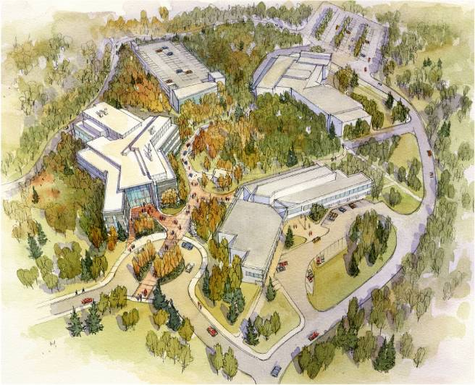
Contributors:
William Spindle: Vice Chancellor, Administrative Services
Stuart Roberts: Associate Vice Chancellor, Budget and Finance
Chris Turletes: Associate Vice Chancellor, Facilities and Campus Services
Executive Summary
- UAA proposes to construct a Parking Structure and loop road adjacent to the Integrated Science Building (ISB). Such a facility and road will;
  - Meet code requirements of the ISB
  - Meet campus needs of improved parking and traffic flow on the East Campus of the University
  - Provide the best parking and traffic solution from an aesthetic and functional perspective
  - Be environmentally responsible by minimizing the building footprint and impact on surrounding wetlands
- This project shall be funded using primarily debt financing with help from ISB general funds targeted for parking and the loop road. State capital appropriation funds of $3.5M will be used to pay for the design and a portion of the loop road. User fees derived from parking revenues represent over 99% of the annual funding requirement. Additionally, a very small amount of fund support will come from the parking garage auxiliary food service operation ($10,000) that will take place in the auxiliary building, attached to the parking structure. The use of parking revenue for this project is appropriate as it will help improve the overall parking and traffic flow of the University in an area that has traditionally been a traffic problem area.
- UAA proposes to use a Construction Manager (CM) Adviser arrangement with Cornerstone to manage the project. Under this process Cornerstone will manage the construction site as an advisor to UAA. UAA will bid out individual trade contracts for the construction of the parking structure. This process is superior to having a separate general contractor construct the parking structure for the following reasons;
  - Limited staging, access, and construction area
  - Allows the Contractor to manage the site, connection and interfaces with roads, and utilities.
  - Keeps the General Contractor responsible for site permits and interface management.
  - CM has been involved in the project development. Maintaining this relationship extends that continuity and understanding of the project and cost savings.
  - Eliminates the need to commit additional UAA staff to manage an additional project team.
  - Higher cost associated with maintaining two contractors on site.
- A loop road will be constructed to facilitate traffic flow to the ISB and other facilities in on the east end of the campus.
- Debt service for this project has been projected by UAA for the past two years. See attachment C for UAA’s latest projected debt service requirement. When the parking structure is included in the projected debt service, the debt load is less than 2 percent of total unrestricted funds.
Background and Needs Analysis

Beginning in Spring 2001, UAA began preliminary programming for the Integrated Science Building (ISB). The current ISB is designed at 120,000 gsf and located on East Campus. The Municipality of Anchorage (MOA) planning and zoning regulations (also known at Title 21), require associated building parking at a proportion of one space for every 300 gsf of construction, or 400 new parking spaces for this project.

There are several parking and site issues that UAA and the ISB project design team have studied in relation to this project. Some of the factors impacting decision making on a parking solution for the project are as follows:

- 2005 calculated parking surplus on East Campus was +122 spaces.
- Construction of the ISF reduced the current Admin/Humanities parking lot from 180 spaces to 23 spaces -157 spaces
- ISF construction requires 400 spaces -400
- Total calculated need at this stage of planning +445 spaces

While the parking need could, in theory, be met with a very large surface parking lot, the 2004 Master Plan and the subsequent UAA Parking and Transportation study recognize the value of UAA’s developable land and balancing preservation with development of UAA’s unique landscape. The clear recommendation of the Administration, Municipality and community groups is to build structured parking, for the most efficient parking footprint. The design team has been working on this project in connection with the ISB project since early 2006. The campus leadership has been preparing a business plan for financing and on-going garage operations. Parking user fees will pay for the preponderance of the Parking Garage with a one time subsidy from the unrestricted fund (Approx total $150K). An allocation from the ISB project ($3.5M) will pay for planning and design and part of the loop road construction.

In the spring of 2006 the design team working on the ISB was asked to present a concept of a parking structure for consideration as the ISB parking solution. In April of 2006 the UAA Administration concluded a parking garage and a loop road was the best solution for the campus based on the master plan approved in Aug 2004 and a campus Transportation study conducted in 2006. Reasons for the decision were:
- Minimize impact to Woodlands and Wetland
- Minimizes the parking foot print
- Consistent with the Master Plan and Transportation Plan
- Consistent with Municipality and Community Expectation
- Minimizes the cost of operating surface lots
- Keeps parking close to Fine Arts, Administration and Integrated Science Facility
- Best use of available land

In June of 2006 at the Kodiak BOR meeting the Integrated Science Building was presented for Schematic Approval. In that package the Parking Garage was shown and discussed as the parking solution for the ISB and would be primarily funded separately. The Board requested a business plan be submitted with the Parking Garage and Loop Road Project Approval. In November of 2006 the Parking Garage and Loop Road was in the Capital Request for receipt authority in the amount of $9M. In the spring of 2006 the receipt authority was increased to $14M. In April of 2007 at the Homer meeting, the Formal Project Approval for the Parking Garage and Loop was presented along with a rudimentary business plan. The BOR approved the Formal Project Approval and directed that the business plan be presented to the Finance committee for their approval. At the Dec 2007 BOR meeting the business plan will be presented to the Finance Committee for approval and the Schematic Approval of the Parking Structure and Loop Road will be presented the Facilities Committee.

Design Considerations

The project scope is to construct a 3 story, 445 space parking garage on East Campus in association with the Integrated Science Building project. The project site is located north and west of the existing Fine Arts, north of Administration/Humanities buildings, and north and east of the ISB (see attached site plan). The other major elements of the project scope are to construct a loop road that extends the existing Fine Arts Lane and connects it to the existing Alumni Loop. The road connection will serve the East Campus buildings, provide emergency and service access to the Integrated Science Building, and provide a second means of egress from the existing Fine Arts parking lot. An auxiliary building which will house the elevator, stairs, mechanical and electrical support for the garage and provide a 4,000 gsf space for a retail coffee/foodservice area to serve this east campus area. In the future, this garage will serve as additional parking for the UAA Sports Arena to be sited northeast of the proposed project site. The primary need for the project is to provide Parking for the ISB. The secondary programmatic needs addressed by the project are (1) to connect East Campus and East Central campus with a loop road, thereby improving access to both campus zones, (2) promote efficient pedestrian paths of travel between buildings, (3) and improve the operation and effectiveness of the campus shuttle system.

The proposed Parking Facility consists of the parking garage and the associated amenity building. Comprising 445 parking stalls (including; 8 ADA accessible stalls, 2 van stalls, and 23 small stalls) and approximately 4,000 square feet of retail space; the parking facility will play a significant role in the development of UAA’s East Campus. The centralized siting of the proposed parking facility between the Integrated Sciences Building and the Fine Arts Building ensures that it will be a key defining element of the newly formed East Campus Quadrangle. This position, as well as serving as a gateway to future expansion efforts, demands considerable attention. The continuous extension of the Universities’ existing pedestrian spine will travel along the east façade of the ISF then curve east along the south façade of the proposed amenity building eventually turning south to terminate at the back door of the Fine Arts Building. The location of the amenity building with its quadrangle frontage and anticipated high level of pedestrian traffic is well suited for prime retail lease space and has great potential as a new hub of social interaction on UAA’s East Campus. The completion of the East Campus Parking Facility is scheduled to be coincident with the completion of the Integrated Science Building.

New and revised vehicular and pedestrian traffic infrastructure plays a critical role in the expansion of UAA’s East Campus. The scope of the proposed parking facility encompasses a substantial portion of that effort. Access to the garage will be accomplished via a proposed new loop road that redirects/extends Alumni Loop northeast around the new Integrated Science Building turning east around and along the north end of the proposed parking facility and finally terminating at the northwest corner of the Fine Arts surface lot. The loop road and garage as designed are located in or encroach upon areas currently identified as Class A wetlands. A wetlands permit has already been obtained from the US Army Corps of Engineers. Significant cut, fill and retaining measures will be required for the loop road to successfully navigate the topographically varied terrain. Vehicular access to the parking garage is by direct independent drives at each level. Access to tier one is accomplished via a short driveway off the proposed Integrated Science Building service access loop. Access to tiers two and three occurs on the north face; at the center of the second tier and at the northeast corner of the third tier. The proposed service loop for the new ISB will be the method of access to the backside of the retail lease space. Along with the loop road and access driveways, the construction of the proposed parking facility would include pedestrian pathway improvements, trail extensions, realignments and new paths and sidewalks. The proposed parking facility is sited such that the Fine Arts Building the Administration Building and the new Integrated Science Building are all within a three minute walking radius of the parking garage.

Design Alternatives
Parking Structure
A three level 445 space structure located adjacent to the ISB covering approximately 1.3 acres.

Parking Lot(s)
445 surface parking spaces located north and east of the ISB facility and Arts building parking lot covering approximately 5 acres.

Combination
Combination of a two level parking structure and surface lots covering approximately 3.5 acres.
Comparative Costs

- Parking garage with loop road
  - Total Project cost - $17.16M approved by BOR April 2007
  - Cost to construct - $13.5M (October 2007)
    - Loop road - $2.5M
    - Amenities Building - $3.2M
  - Construction cost per stall - $30.3K ($18.6K not including road/building)
  - Total project cost per stall - $38K
  - Operating cost: $75K per year

- Surface lot construction with loop road
  - Total projected cost - $7M (significant site topography work required)
  - Wetlands permitting and mitigation
  - Municipality, neighborhood boards and UDC approvals required
  - Construction cost per stall - $12.2K+
  - Total cost per stall - $ 15.7K
  - Operating Cost: $200K per year

- Combination parking garage/surface lot with loop road
  - Total projected cost $ 13.5 M
  - Wetland permitting and mitigation
  - Municipality, neighborhood boards and UDC approvals required
  - Construction cost per stall - $ 27.0K
  - Total cost per stall - $ 30.3K
  - Operating Cost: $175K

- Comparison costs
  - Total project cost comparisons
    - Ted Stevens International Airport total project cost per stall - $57K
    - Downtown Anchorage parking garage total project cost per stall - $53K
  - Construction cost per stall
    - Providence Hospital construction cost per stall - $21K
    - South Central Foundation construction prices per stall - $27K
Risk Analysis
Parking Structure
Funding for the structure would come primarily from increases of existing parking rates and creation of new parking fees. There is some risk associated with this action, however we believe the fee and rate increases are reasonable, can be associated with improving parking on campus and can be justified to our students and staff. The rate increases are also consistent with UAA’s overall parking management strategy. A significant aspect of that strategy is to encourage use of alternate transportation methods to access the UAA campus. As rates increase we expect staff and students to take greater advantage of public transportation and car pooling options.

Parking Lot(s)
Parking lots would require the most land of the considered alternatives. There is a scarcity of land available for this and other construction purposes. At this time there are only approximately 60 non-contiguous acres on the UAA campus which are suitable for future development. Because there is so little land available, unnecessary use of it for parking puts further development and facility growth at risk. It would be necessary to reclaim additional surface lots at some point in the future to allow the construction of facilities required to support growth.
Use of parking lot(s) would force students and staff to walk greater distances to and from their parked vehicles. We believe this creates some level of safety risk over and above that provided by close in parking.
Surface parking lots create environmental hazards. Runoff from the lots contains hazardous chemicals dropped from vehicles. Minimizing surface area used for parking reduces the amount of hazard introduced to the local environment. Surface lots providing the same amount of parking space as parking structures are spread out over much larger areas thereby complicating management of the hazard. Parking structures minimize the footprint and provides an opportunity to more effectively and efficiently manage runoff.
Expansive surface lots complicate traffic flow and limit alternatives for accommodating it.
Destruction of wild areas on campus risks a backlash from citizens concerned with such developments in Anchorage. This risk is amplified when other alternatives are available.

Combination
The combination solution brings all the risks associated with the other two alternatives. It would cost less than a 100% parking structure but more than 100% parking lots. It would have all the risks associated with parking lots if somewhat tempered by a moderately reduced footprint. This solution is not considered feasible because it builds part of the garage without benefit of economy to scale (more floors) and builds a surface lot. The collective foot print is greater. The exposed area is larger increasing the costs associated with lighting, plowing, sanding painting and crack sealing. Contractor would have to clear and do earth work in excess to what would be required for the garage. Surface lots would be further away from the buildings and would get limited use.

Change in Course Risk
In addition to the risks noted for the parking lot and combination solutions, any course of action other than a parking structure as currently designed will risk financial loss and ISB project delay. By April of 2006 UAA had determined that a parking structure was the optimal parking solution and work to that end has been executed. Approximately $1M has been invested in design, permitting and other work associated with implementing the project. A different solution at this juncture would need to be designed. That design would need to be submitted through the UA Board of Regents and Municipal review and approval processes. The permitting process for surface lots would be extraordinarily difficult and lengthy due to their location adjacent to wetlands. Significant discussion with neighborhood boards would also be required. We estimate this work would cost approximately $700K. Assuming a redesigned project is approved, completion would be delayed for 12 to 18 months. Lack of sufficient parking space when the ISB is completed may delay or prevent issuance of a Certificate of Occupancy for the building.

Cost Risk of Delaying Construction of a Parking Structure

It is widely reported in the construction industry that the cost of construction in Alaska in increasing at approximately 8% to 12% per year*. The primary reasons for the increases are material costs and significant demand on construction resources.

The Universities risk free rate of return on investments is currently running at approximately 5%. Even using a conservative estimate, the cost of construction is inflating by at least 8% per year. The net result is that the University realizes an economic loss by delaying construction projects. For example, the cost of constructing the parking structure today is $17,160,000. The cost to build it one year from now would be 8% more or approximately $18,532,800, an increase of $1,372,800. During the same period the University would have earned approximately $858,000 had it invested the $17,160,000. The difference of $514,800 represents the actual economic loss to the University caused by delaying the project for one year.

Clearly there is significant cost associated with delay in constructing a parking solution.

* Bureau of Labor Statistics (BLS): www.bls.gov/cpi for CPI, www.bls.gov/ppi for PPIs
* AGC’s Construction Inflation Alert, October 2007
* Ken Simonson, Chief Economist, AGC of America, simonsonk@agc.org, from U.S. government sources

* Vol. 7, No. 39 October 9-15, 2007 The Data DIGest

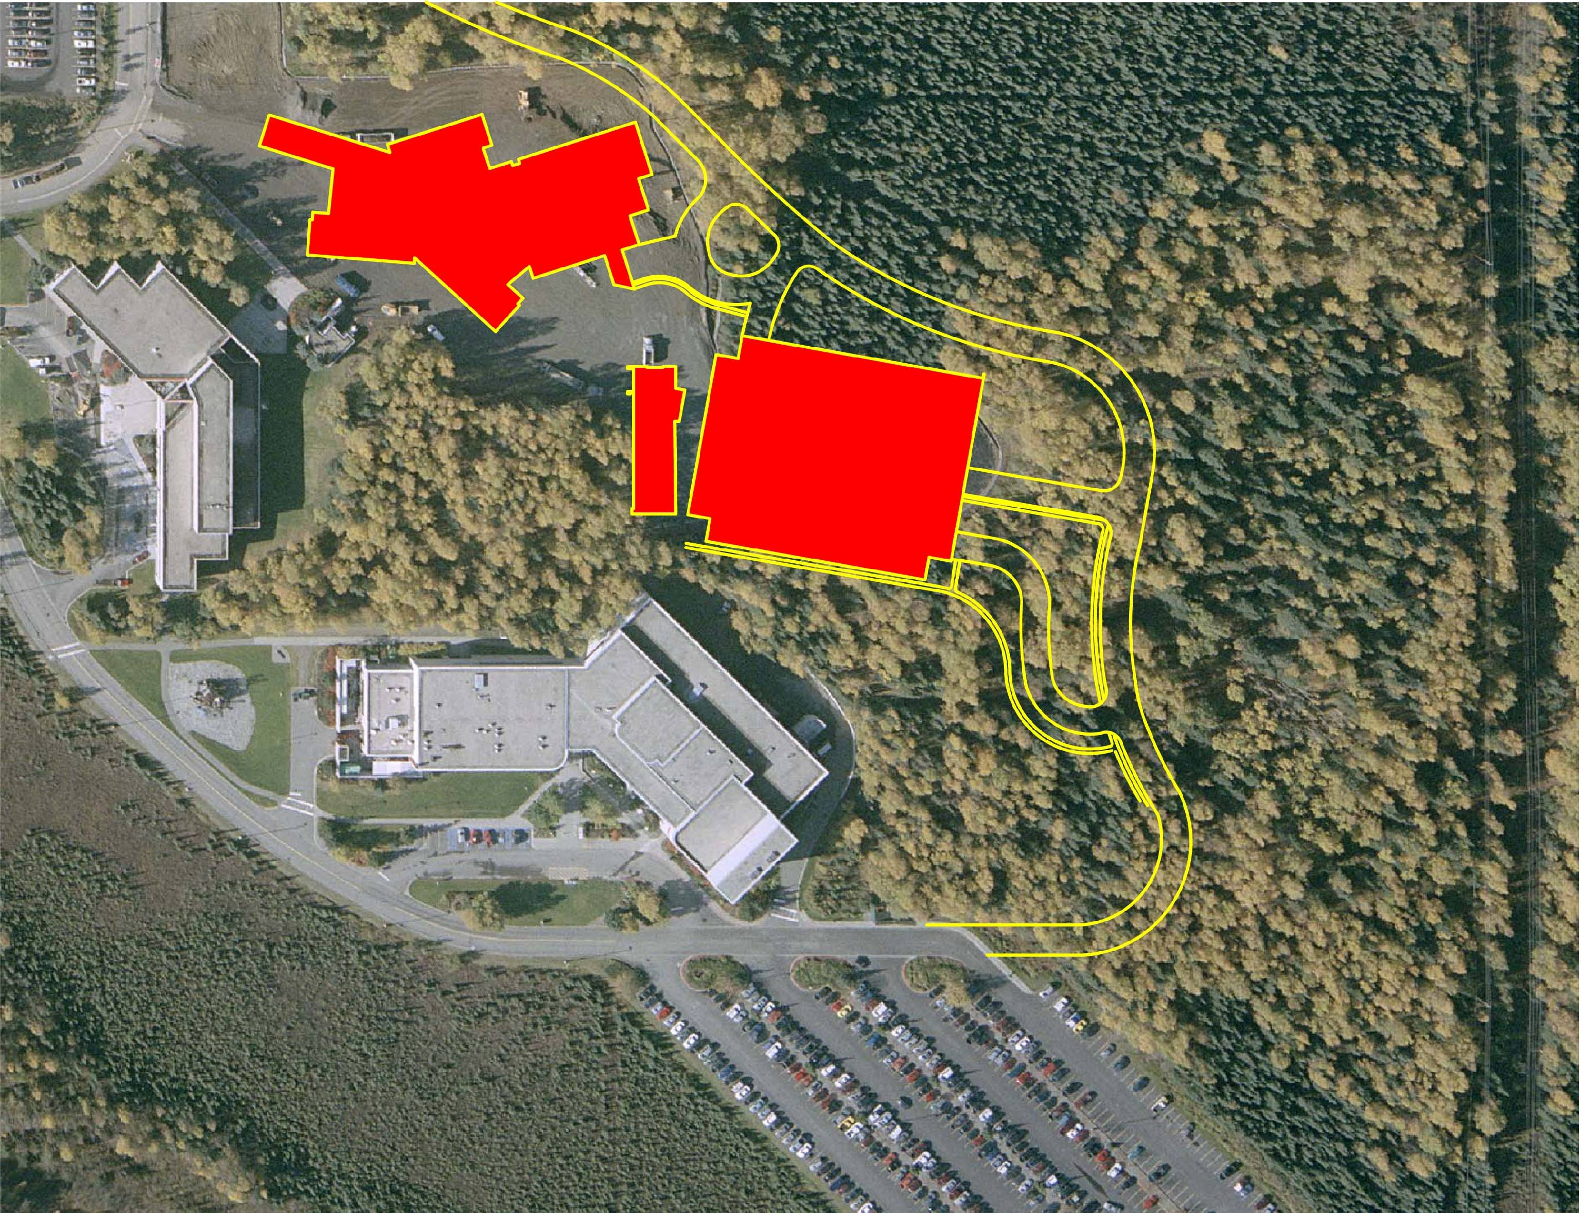

Parking Garage Solution

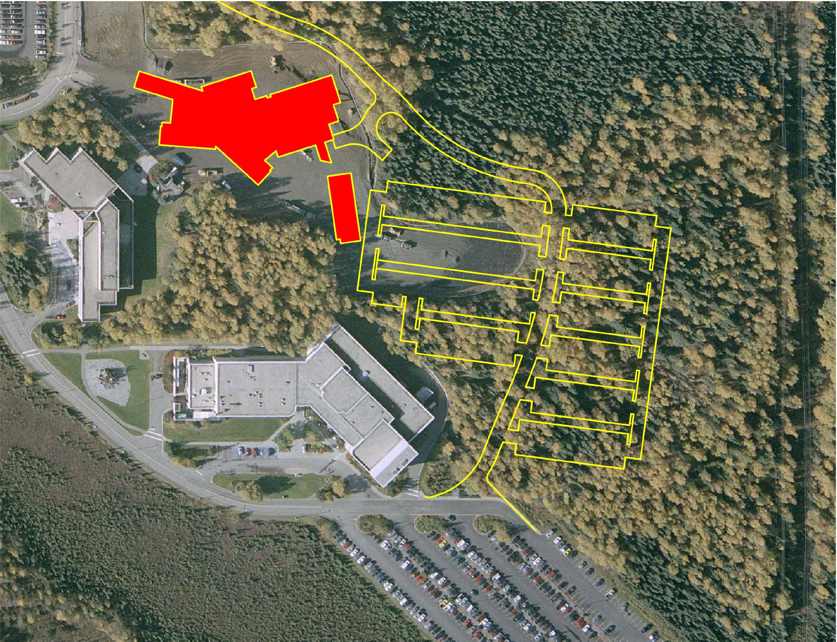

Parking Lot Solution

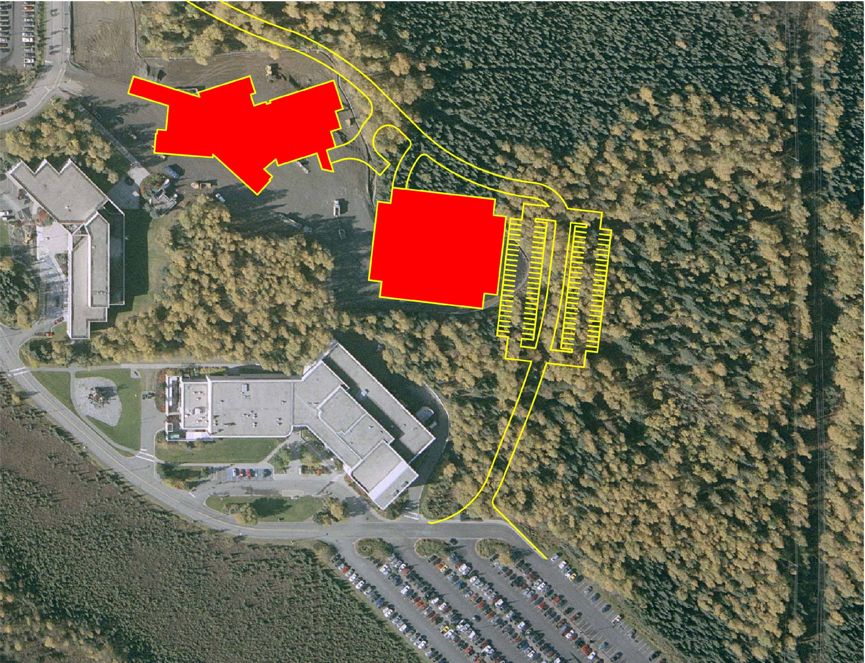

Combination Garage/Lot Solution
Contract Management

UAA proposes to use a Construction Manager Adviser arrangement with Cornerstone to manage the project. Under this process Cornerstone will manage the construction site as an advisor to UAA. UAA will bid out individual trade contracts for the construction of the parking structure. This process is superior to having a separate general contractor construct the parking structure for the following reasons:
  - Limited staging, access, and construction area
  - Allows the Contractor to manage the site, connection and interfaces with roads, and utilities.
  - Keeps the General Contractor responsible for site permits and interface management.
  - CM has been involved in the project development. Maintaining this relationship extends that continuity and understanding of the project and cost savings.
  - Eliminates the need to commit additional UAA staff to manage an additional project team.
Higher Cost As A Result of Duplication of Effort by Two Contractors

The cost of the duplication of effort of two contractors will increase the cost of the parking structure as much as 5% of the total cost of the structure. (Estimated additional cost: $630,000). The higher costs are a result of but not limited to:

- The additional cost of clearing trees and brush, earthwork and grading of approximately an additional acre of land for another staging area and/or constructing an additional access road to a second jobsite.

- Additional General Condition setups which include the cost of the temporary field office, fencing and security, materials storage and protection, site security, utilities, insurance and permits.

- The need for another project management team and associated costs for a second contractor. If the parking structure is incorporated into the current contract Cornerstone has stated they would designate the same project management team currently being used for ISB.

Recommendation

After considering these various options using the specified design criteria UAA administration decided construction of a parking structure adjacent to the ISB is the best choice.
- It is consistent with the UAA master plan
- It minimizes the use of limited and high value land available to UAA for future growth
- It is the most environmentally friendly solution
- It will provide the most safety for students and staff
- It provides the opportunity to optimize traffic flow
- It is the least costly to operate and maintain. Maintenance and operation of surface lots would cost $200K per year as compared to $75K for a parking structure. The additional cost is due to greater sanding, plowing, cleaning, asphalt sealing and line painting requirements. Surface lots would also require higher output lighting resulting in greater power consumption and higher bulb cost.
- It alleviates congestion on East campus
- The parking structure was integrated into planning for the ISB project and was approved by the BOR in April 2007. Pursuant to that approval UAA has spent approximately $800K in design of the structure and has initiated the Municipal review process.
- Constructing now takes advantage of the time value of money
This recommendation is consistent with similar decisions made by the Ted Stevens International Airport, Downtown Parking Authority, Providence Hospital and the South Central Foundation. All these organizations when faced with the same issues as UAA chose to build parking structures over any other parking solution.

Use of surface lots or a combination of surface lots and a small parking structure should only be thought of as very costly and temporary solutions. Because of the shortage of buildable land available to UAA, it will be necessary at some point to reclaim the land covered by the surface lots to make room for the construction of new facilities. At that point the lack of available land will limit if not eliminate the option of using surface lots and make a parking structure the only viable option.

Summary Parking Structure Financials (in thousands)

Project Financial Requirements
Total Project Cost (with cost of financing) | $ 17,000.0
Integrated Science Facility Funding | <$ 3,500.0>
Total Financing Requirement | $ 13,500.0

Annual Expenses
Expense | FY08 | FY09 | FY10 | FY11
Debt Service | $ 97.0 | $ 572.0 | $ 872.0 | $ 872.0
Operating Expenses | $ 0.0 | $ 0.0 | $ 153.8 | $ 157.7
Total Expenses | $ 97.0 | $ 572.0 | $ 1,025.8 | $ 1,029.7

Annual Revenue
Source | FY08 | FY09 | FY10 | FY11
Campus-Wide Parking User Fees | $ 0.0 | $ 809.5 | $ 809.5 | $ 1,038.8
Parking Garage (only) Concession Sales | $ 0.0 | $ 0.0 | $ 10.0 | $ 10.0
Total Revenue | $ 0.0 | $ 809.5 | $ 819.5 | $ 1,048.8
Net From Operations | $ <97.0> | $ 237.5 | $ <206.3> | $ 19.1
Available Parking Fund Balance at Year End | $ 288.4 | $ 525.8 | $ 319.5 | $ 338.6

User fee revenue will be provided by a 20% increase in existing permit rates and the addition of a transportation fee, in person permit renewal fee and summer enforcement. Additional rate increase will occur in FY11. Detail financial projections are found in attachment A. Attachment B contains parking rate details. Attachment C contains an analysis of the impact servicing this debt will have on UAA.

